## Quota allocation policies in U.S. federal fisheries management and implications for climate resilience

Christopher M. Free1,2,3, Zoë J. Kitchel1,4, Matthew Seeley5, Allison Shields5

1 Mola Mola Analytics LLC, Santa Barbara, CA, 93101, USA

2 Marine Science Institute, University of California, Santa Barbara, Santa Barbara, CA, 93106, USA

3 Bren School of Environmental Science and Management, University of California, Santa Barbara, Santa Barbara, CA, 93106, USA

4 Vantuna Research Group, Occidental College, Los Angeles, CA, 90041, USA

5 Environmental Defense Fund

### Abstract

Developing quota allocation policies, which divide fishing catch or effort between regions, sectors, subsectors, individuals, and/or seasons, is one of the most important and contentious processes in fisheries management. These policies often aim to advance fairness and equity goals by preserving levels of historical participation and access. However, this reliance on historical patterns makes allocation policies vulnerable to climate change, which is shifting the accessibility of marine resources among historical and new participants. Despite this, there is little guidance on best practices for adapting allocation policies to climate change. In the United States, regional flexibility to design locally relevant allocation policies has innovated a diversity of approaches that can be studied for their climate vulnerability and/or adaptivity. Here, we synthesize the diverse allocation policies used to manage U.S. federal fisheries (491 stocks, 42 management plans, 8 regions) and evaluate the vulnerability of these policies to climate change. We find that allocation policies are used to manage 46% of federally managed stocks. Although most policies are based on historical catch, many include features that promote climate adaptiveness, including the ability to transfer quota between states, sectors, or individuals; adjustment of allocations based on current resource distribution or abundance; set aside of quota to support research and experimentation; and gradual phase in of policy changes. Ultimately, we provide eight transferable recommendations for improving the ability for allocation policies to advance their fairness and equity goals under climate change.

### 1. Introduction

Climate change is shifting the abundance, distribution, and phenology of harvested marine resources, which is challenging the ability for managers to maintain the conservation and socioeconomic goals of global fisheries [(IPCC, 2019)](https://www.zotero.org/google-docs/?7ZLMgb). To achieve conservation goals, managers must establish catch or effort controls that maintain sustainability as stocks experience climate-driven shifts in their productivity and distribution [(Gaines et al., 2018)](https://www.zotero.org/google-docs/?jxMPcE). To meet socioeconomic goals, managers must further ensure that access to shifting resources remains fair and equitable despite changing oceanographic conditions [(Tokunaga et al., 2023)](https://www.zotero.org/google-docs/?wgAx8N). This can be achieved through a combination of management policies ranging from permitting, which governs who can access resources, to quota allocation, which governs how much catch or effort is available to those with permitted access [(Ojea et al., 2017)](https://www.zotero.org/google-docs/?zOVq6Q).

Quota allocation is arguably one of the most important and contentious processes in fisheries management as it dictates how access is shared among fishery participants. While the establishment of catch limits is a largely scientific and objective process [(Punt, 2010)](https://www.zotero.org/google-docs/?fyT3Nr), decisions about how to distribute the resulting quota is more subjective and depends on complex socioeconomic considerations [(W. E. Morrison & Scott, 2014)](https://www.zotero.org/google-docs/?PSeZ5f). Quota allocations are often made between jurisdictions (e.g., international, regional, state), sectors (e.g., commercial, recreational, tribal, research), subsectors (e.g., gillnets, longlines), individuals (e.g., catch shares), and seasons. Allocations are often based on relative levels of historical catch or effort as they frequently aim to maintain proportional access for fishing communities historically dependent on fishery resources [(Cox, 2009; FLSF, 2010; Lynham, 2014)](https://www.zotero.org/google-docs/?uu5QQS). However, climate change is causing rapid departures from historical conditions, which can lead to unfair, inequitable, and inefficient resource use when access is based solely on historical dynamics [(Palacios-Abrantes et al., 2020, 2023; Pinsky et al., 2018; Vogel et al., 2024)](https://www.zotero.org/google-docs/?YXHll1). As a result, fisheries managers will need to develop procedures for adapting quota allocation policies so that they continue to advance their fairness and equity objectives despite changing ocean conditions.

The challenge posed by climate change is perhaps most direct for spatial quota allocation policies as climate change will rearrange the distribution of stocks. Spatial allocations, which allocate quota across different management areas (e.g., countries, regions, states), generally aim to ensure that harvest is proportional to either the biological availability of the resource or the historical dependence of fishing communities on the resource. However, climate-driven shifts in the distribution of marine species imply that historical benchmarks used to set spatial allocations will not reflect future distributions [(Palacios-Abrantes et al., 2020, 2023; Pinsky et al., 2018)](https://www.zotero.org/google-docs/?K7u3lE). This can present a number of conflicts, inequities, and inefficiencies. For example, if allocations are not updated to reflect shifted distributions, some fishing communities may be unable to capitalize on increases in local availability, which would be especially challenging if other species in their portfolio are negatively impacted by climate change [(Cline et al., 2017; Samhouri et al., 2024)](https://www.zotero.org/google-docs/?0V6wHP). Worse still, they may be at increased risk of closure if they are unable to avoid the newly abundant yet tightly regulated resource. Furthermore, vessels from a region maintaining its historical access rights may need to travel farther to fulfill their quota [(Young et al., 2019)](https://www.zotero.org/google-docs/?WNJNb9), increasing both their costs, safety concerns, and carbon emissions [(Papaioannou et al., 2021; Scherrer et al., 2024)](https://www.zotero.org/google-docs/?iiJYxB). Thus, there is an urgent need to develop frameworks for adapting spatial allocation policies to climate change.

The allocation of quota between and within sectors has less direct though still important connections to climate change. Allocations between sectors guarantee access for all sectors and, like spatial allocations, are often allocated in proportion to historical dependence [(Edwards, 1990)](https://www.zotero.org/google-docs/?k2dXtw). However, climate change is pushing resources deeper [(Pinsky et al., 2013)](https://www.zotero.org/google-docs/?Z1Ulke), which could challenge the ability for nearshore recreational fisheries and/or small-scale commercial vessels to attain their historical quotas [(Papaioannou et al., 2021)](https://www.zotero.org/google-docs/?BrPyJ3). Allocations between gears have similar goals, but can also be used to limit effort by gears with larger bycatch or habitat impacts [(Jenkins & Garrison, 2013)](https://www.zotero.org/google-docs/?nzit9I). However, climate change is also altering bycatch patterns [(Free, Anderson, et al., 2023)](https://www.zotero.org/google-docs/?74BnBP), which could exacerbate bycatch issues if allocations based on historical patterns are maintained. Finally, allocations between individuals or groups (e.g., fishing cooperatives or communities), often termed “catch shares”, can improve safety-at-sea by slowing the race to fish [(Birkenbach et al., 2017)](https://www.zotero.org/google-docs/?AvjsQW) and improve sustainability by better aligning conservation and economic incentives (i.e., catch shares only hold value if a stock is healthy and the quota is large) [(Costello et al., 2008)](https://www.zotero.org/google-docs/?jbY919). However, these policies are also largely established based on historical catch patterns [(Lynham, 2014)](https://www.zotero.org/google-docs/?Qyf9fG), which makes them vulnerable to climate change [(Tokunaga et al., 2023)](https://www.zotero.org/google-docs/?rS5zvY). Furthermore, catch shares often lead to less diverse fishing portfolios [(Holland et al., 2017)](https://www.zotero.org/google-docs/?wRFnQm), which can reduce resilience to climate change.

The laws governing U.S. federal fisheries management mandate that allocation policies be fair, equitable, and transparent, but gives regional managers immense flexibility in how they achieve these goals. The Magnuson-Stevens Fishery Conservation and Management Act, the primary legislation governing U.S. federal fisheries, provides ten National Standards to define management requirements, of which National Standard 4 directly relates to quota allocations (MSA, 2007). This provision specifies that allocations must be *“(1) fair and equitable to all such fishermen; (2) reasonably calculated to promote conservation; and (3) carried out in such manner that no particular individual, corporation, or other entity acquires an excessive share of such privileges”* [(§ 600.325 National Standard 4—Allocations, 1998)](https://www.zotero.org/google-docs/?H8DCDk). Given the absence of practicable alternatives, both official guidance and adopted practices have generally aimed to be fair and equitable by maintaining historical access and harvests, though with additional considerations for new entrants, bycatch, economic efficiency, and many other factors [(Plummer et al., 2012)](https://www.zotero.org/google-docs/?m6toJi). This gives the eight regional Fishery Management Councils (FMCs) (**Figure 1**) flexibility to design allocation policies tailored to their specific socioeconomic and ecological contexts. However, these approaches may have different strengths and weaknesses in their ability to maintain fairness and equity under climate change.

The U.S. has been expanding guidance on improving the adaptiveness of allocation policies, but this guidance has yet to explicitly consider climate change. In 2011, the U.S. National Marine Fisheries Service (NMFS) launched an effort to provide more detailed guidance on allocation [(Lapointe, 2012)](https://www.zotero.org/google-docs/?zOP86q). This process began with a review of the allocation policies used in U.S. federal fisheries management [(W. E. Morrison & Scott, 2014; Plummer et al., 2012)](https://www.zotero.org/google-docs/?RGBREf), which provided the basis for subsequent guidance on criteria for triggering the review of allocation policies [(W. Morrison, 2016a)](https://www.zotero.org/google-docs/?4zn9pf) and factors to consider when conducting such reviews [(W. Morrison, 2016b, 2017c)](https://www.zotero.org/google-docs/?OHaQNz). This guidance, which was cemented as national policy between 2016 and 2017 [(W. Morrison, 2017b, 2017a)](https://www.zotero.org/google-docs/?AzAwDV), calls for an adaptive process for continually evaluating whether allocation policies are meeting management objectives and for adjusting these policies when objectives are not being met. These policies suggest that the review of an allocation policy could be triggered based on a tracked performance indicator or public input or at regular time intervals. They also highlight that the ability to transfer quota between states, sectors, or individuals offers in-season adaptability. While both of these guidelines provide some inherent climate resilience, the connection to climate change is not explicit, and more guidance on strategies for climate-adaptive allocation policies is needed [(US GAO, 2022)](https://www.zotero.org/google-docs/?AZ776n).

In this report, we synthesize the diverse allocation policies used to manage U.S. federal fisheries, evaluate the vulnerability of these policies to climate change, and provide recommendations for increasing the climate-adaptiveness of allocation policies. We begin by cataloging the allocation policies of 491 stocks managed by the 42 fisheries management plans developed by the eight FMCs into a standardized database. This provides a platform for understanding the myriad of allocation approaches taken across the U.S. and for understanding how approaches differ by region and taxa. We then evaluate the vulnerability or adaptiveness of these policies to climate change and offer recommendations for increasing the ability for these policies to maintain equity and fairness under climate change. We draw these recommendations from best practices identified from both U.S. and international fisheries management. Since reforming fishery management policies is an intensive bureaucratic process, we identified candidate FMPs and stocks that are sensitive to climate change and would therefore benefit from a policy review. Finally, we conclude the paper by reflecting on how these insights relate to international and state fisheries also seeking to maintain the fairness and equity of their allocation policies under climate change.

### 2. Allocation policies in US fisheries

#### 2.1 Methods

We inventoried the quota allocation policies currently implemented in U.S. federal fisheries management by reviewing all 37 Fishery Management Plans (FMPs), 5 Fishery Ecosystem Plans (FEPs), and their associated amendments for descriptions of their allocation policies (**Table S1**). We prepared a brief summary of each allocation policy to provide a clear and concise description of these frequently complex policies using a consistent structure and terminology. Each summary describes the types of allocation policies used, the recipients of quota, the amount of quota allocated to each recipient, and the basis for the allocation amounts. When necessary, we reviewed documents in addition to the FMPs, FEPs, and amendments to gather this information (e.g., Environmental Impact Statements and Final Rulings in the Federal Register). In some cases, we also summarized the history of changes made to the allocation policy and the motivation for these changes. These historical adjustments provide critical insights into considerations and pathways for adapting allocation policies in response to climate change. However, we only recorded this information when it was readily accessible to keep the scope of the review manageable. The summaries are provided in the following GitHub repository: <https://github.com/zoekitchel/cc_allocation>.

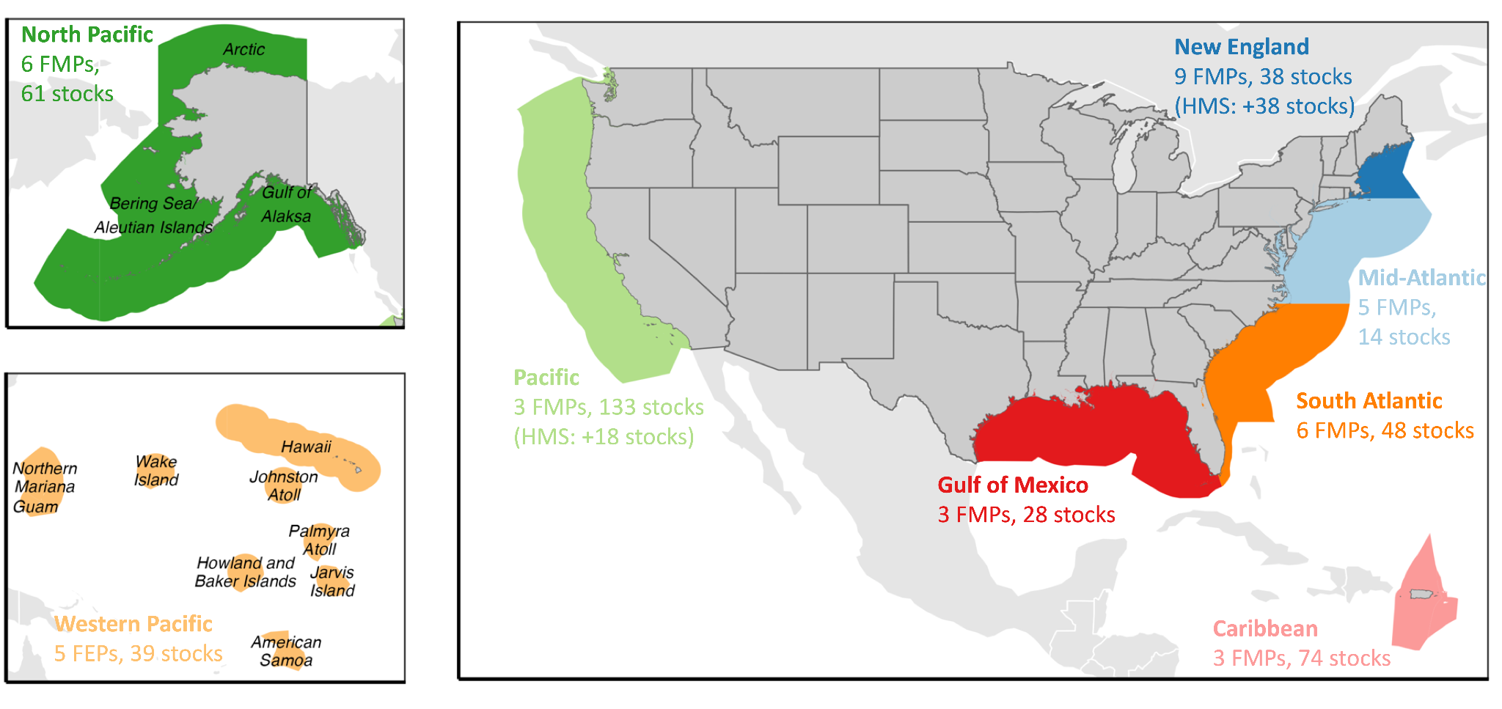

***Figure 1.*** *The jurisdiction of the eight U.S. regional Fishery Management Councils (FMCs) and details on the number of Fishery Management Plans (FMPs) or Fishery Ecosystem Plans (FEPs) implemented by the FMC and the number of stocks managed by the FMC (HMS = highly migratory species).*

We used the summaries to develop a database describing the allocation policies used to manage all 491 federally-managed marine fish and invertebrate stocks with a common set of characteristics. The database summarizes (1) basic information on each stock (i.e., FMC, management plan, species group); (2) the allocation policy types used to manage the stock; and (3) traits of each of the implemented allocation policy types. We classified allocation policy types into five categories: spatial, sector-based, subsector-based, catch shares, or seasonal (**Figures 2 & 3**). A spatial policy allocates quota among countries, states, or other management areas. A sector-based policy allocates quota among commercial, recreational, tribal, and research fleets. A subsector-based policy allocates quota to groups (e.g., gear types, vessel size tiers, product end uses) within one of these sectors. A seasonal policy allocates quota across different seasons. We use “catch shares” as a general term for allocation policies that distribute quota among individual fishermen, groups of fishermen, cooperatives, fishing communities, or other entities, which include individual fishing quotas (IFQs), territorial use rights for fisheries (TURFs), and limited access privilege programs (LAPPs). We excluded limited access permits that were not specifically associated with an effort or catch allocation. We recorded the basis for each allocation type, i.e., whether the allocation amount was derived based on historical catch or effort, equal catch or effort, or an auction. We also recorded the number and identity of geographies, sectors, or subsectors receiving allocations. The structure of the database is illustrated in **Table S1** and the full database is provided in the following GitHub repository: <https://github.com/zoekitchel/cc_allocation>

We confirmed the accuracy of our summaries and database by comparing them to information synthesized in other relevant but less comprehensive reports [(FLSF, 2010; W. E. Morrison & Scott, 2014; Plummer et al., 2012; Tokunaga et al., 2023)](https://www.zotero.org/google-docs/?h8kDbU).

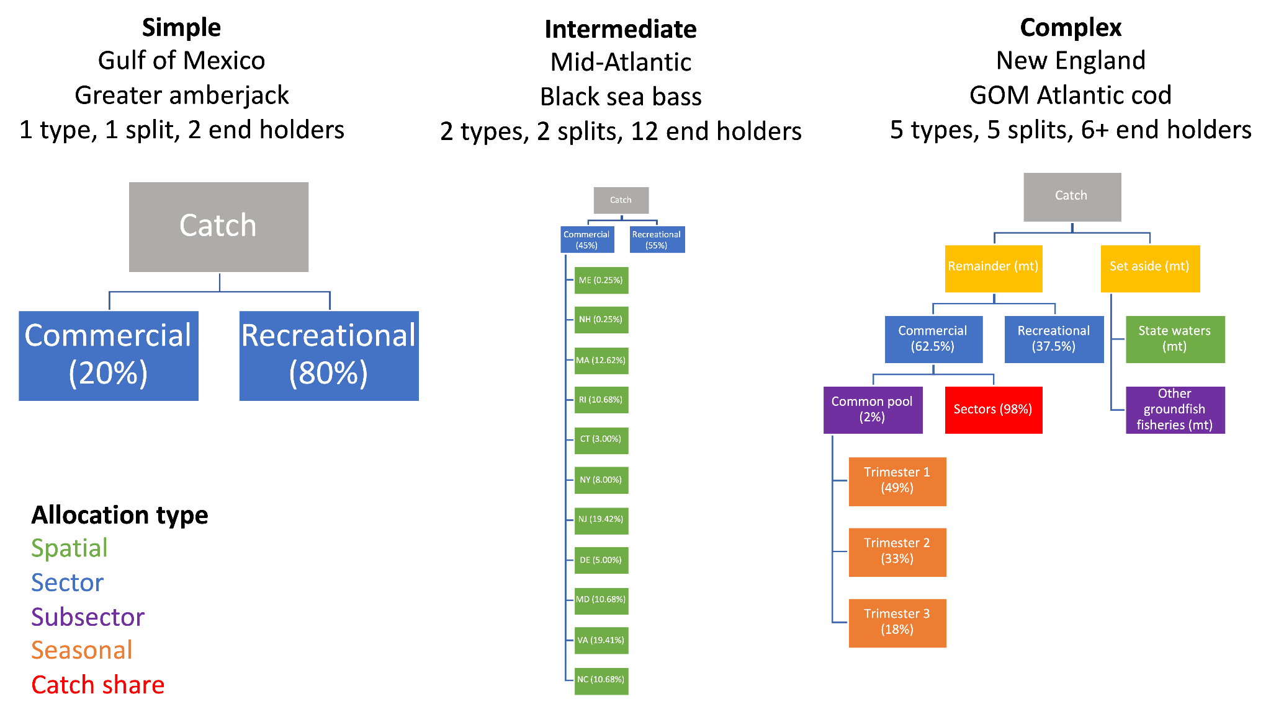

***Figure 2.*** *Flowcharts illustrating examples of quota allocation policies of low, medium, and high complexity. Box color indicates the type of allocation policy.*

#### 2.2 Results

##### 2.2.1 Overview

A large portion (46%; 228 of 491 stocks) of federally managed fish and invertebrate stocks are managed using some form of quota allocation policy (**Figure 3**). Sector-based allocation policies are most common, followed by catch shares, subsector-based, spatial, and seasonal policies. Allocation policies are especially commonly used by the U.S. East Coast FMCs (i.e., the Mid-Atlantic, South Atlantic, and New England).

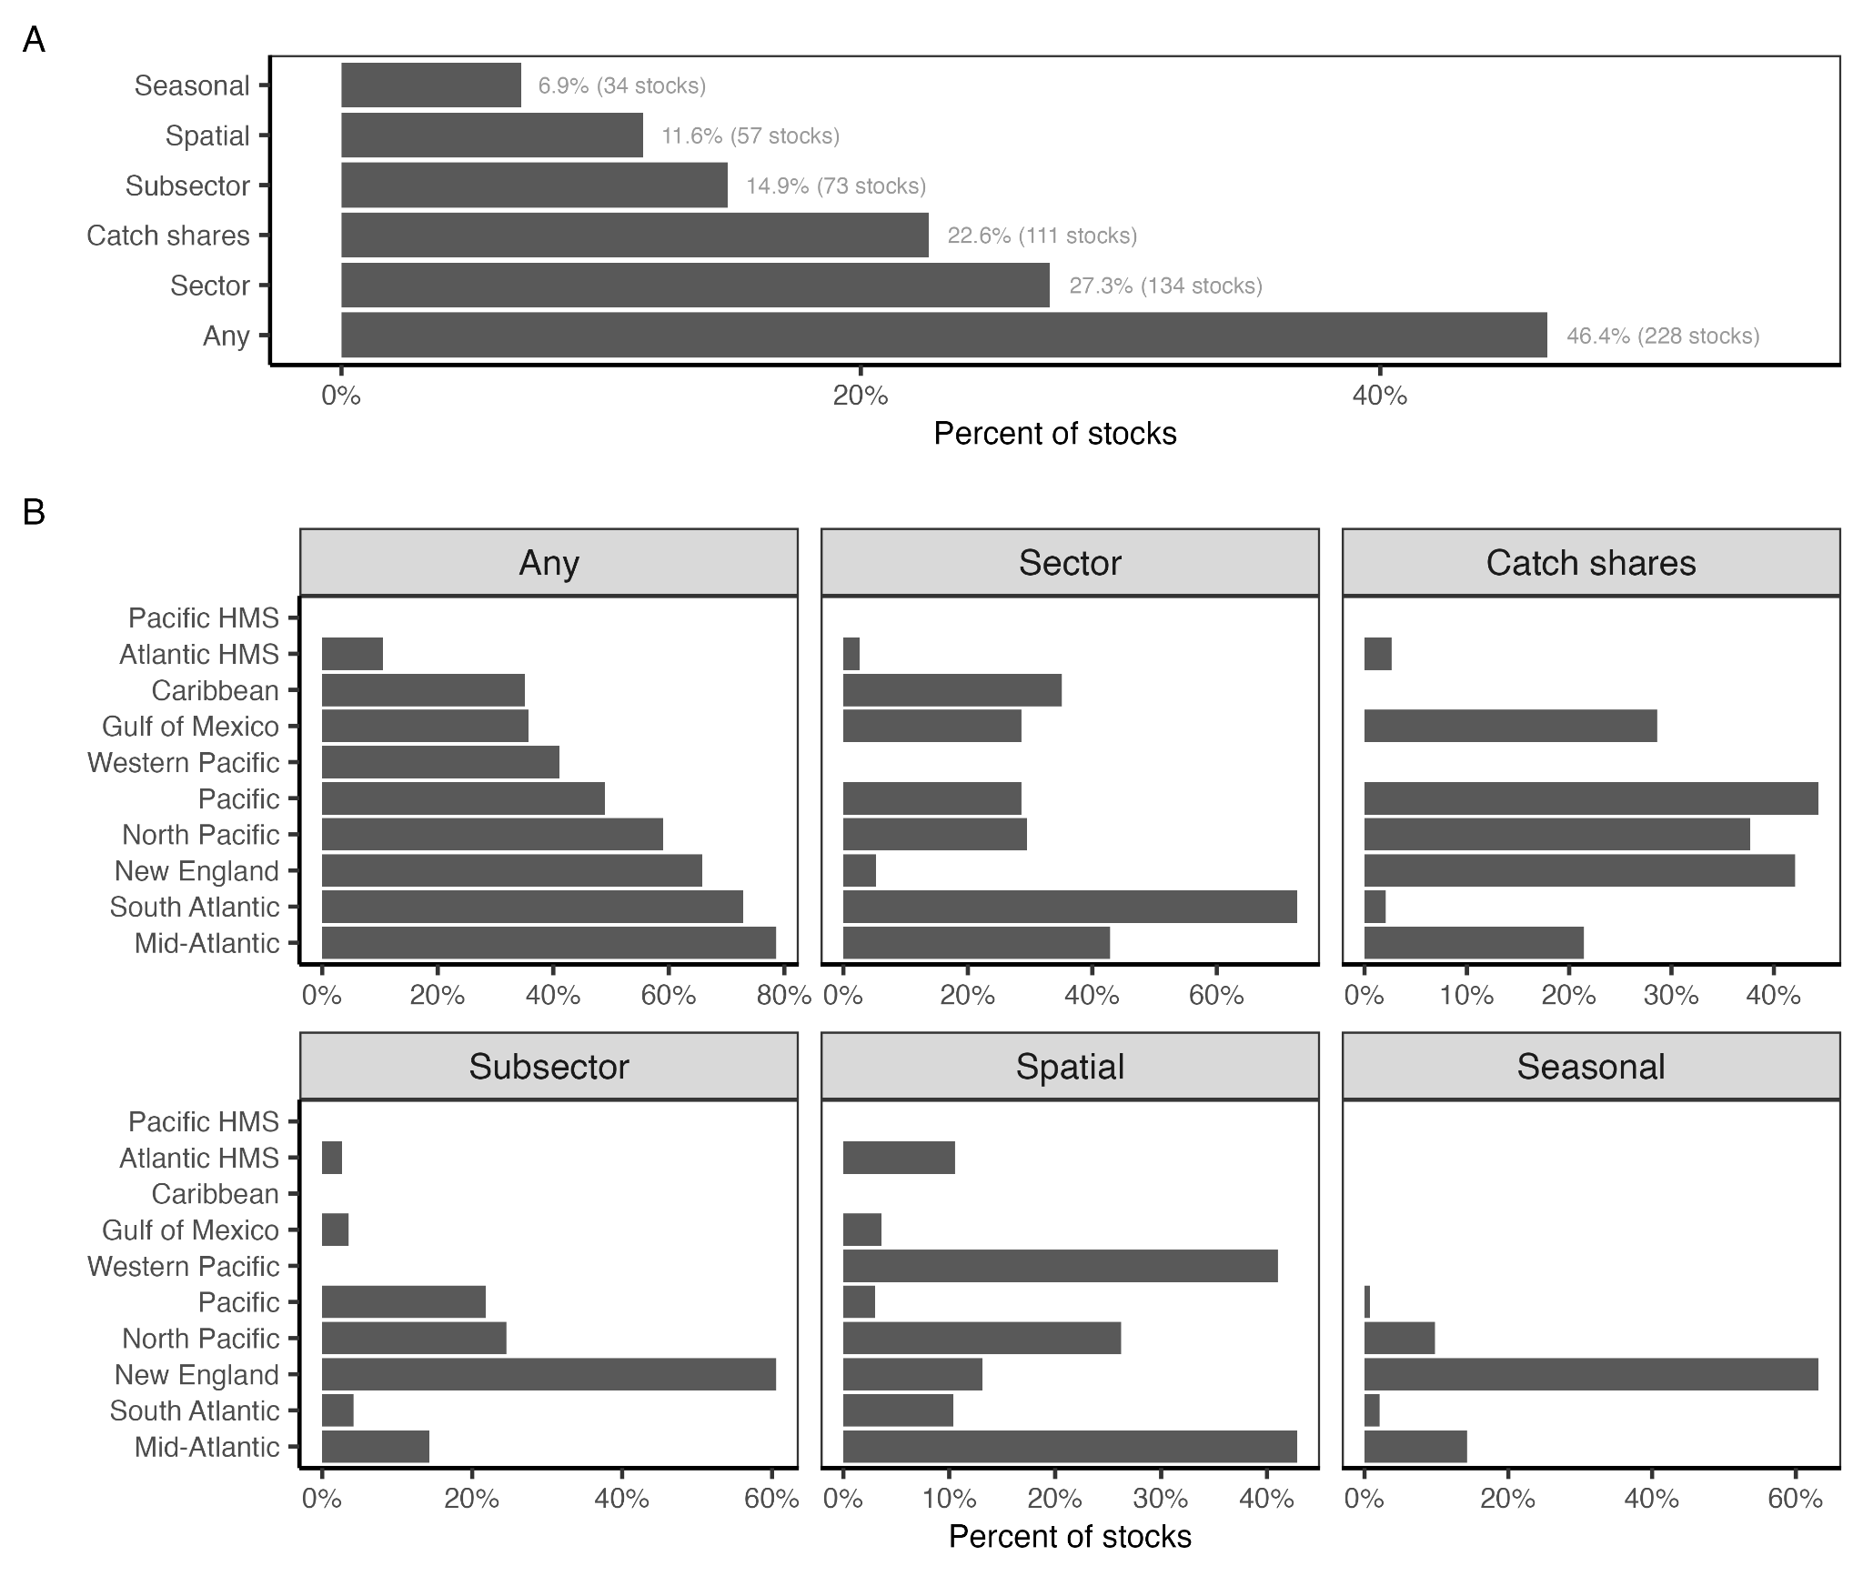

***Figure 3.*** *The percent of federally managed fish and invertebrate stocks managed using quota allocation policies* ***(A)*** *nationwide and* ***(B)*** *by regional Fishery Management Council.*

##### 2.2.2 Spatial allocations

Spatial allocation policies are used in the management of 12% (n=57 stocks) of federally managed stocks (**Figure 3**). The only regions without country-based spatial allocations of transnational stocks are the South Atlantic, Gulf of Mexico, and Caribbean **(Figure 4A)**. The lack of country-based allocations in the South Atlantic is likely due to its distance from an international border (**Figure 1**). The lack of country-based allocations in the Gulf of Mexico, which neighbors Mexico, and in the Caribbean, which neighbors many island nations, is likely due to (1) a lack of data to quantify the transnational distribution of resources and (2) the regional prevalence of reef fish, which exhibit higher site fidelity and more granular population structure than other fish taxa [(Biggs & Nemeth, 2016; Carson et al., 2011; Coleman et al., 1999)](https://www.zotero.org/google-docs/?3d566J). In the Pacific, country-based allocations for coastal pelagic species are based on fixed percentages (**Figure 4B**), despite awareness that these stocks experience dynamic shifts in distribution as a response to oceanographic conditions [(Pozo Buil et al., 2021)](https://www.zotero.org/google-docs/?mhfUsI). In New England, country-based allocations for Eastern Georges Bank haddock (*Melanogrammus aeglefinus*, Gadidae), Atlantic cod (*Gadus morhua*, Gadidae), and yellowtail flounder (*Pleuronectes ferruginea*, Pleuronectidae) are jointly managed by the U.S. and Canada through the Transboundary Management Guidance Committee (TMGC). The TMGC determines annual allocations for all three species by combining both historical landings and current resource distribution according to fisheries independent trawl surveys [(Andrushchenko et al., 2022)](https://www.zotero.org/google-docs/?0D5g6l). This approach is climate-adaptive because it annually adapts to climate-driven distribution shifts. By retaining the influence of historical landings, it also balances current distributions with historical dependence. The policy was implemented in 2003 weighing historical landings at 40% and current distribution at 60% and changed the weighting in 5% increment until reaching the target 90%-10% landings-distribution in 2010 [(Andrushchenko et al., 2022)](https://www.zotero.org/google-docs/?QdbhfL). Such gradual changes, termed “phase ins”, allow time for fleets to adapt to changes in their allocation, which presents a good practice for reducing socioeconomic impacts when changing quota allocation policies.

The Mid-Atlantic and the Gulf of Mexico regions are the only regions to allocate quota among constituent states **(Figure 4A)**. The North Pacific likely lacks state based-allocations because Alaska is the only state in the region. The lack of state-based spatial allocations in the Pacific is likely because Pacific groundfish stocks are often assumed to have stock structure matching state boundaries and thus have state-specific catch limits [(PFMC, 2023b)](https://www.zotero.org/google-docs/?2LJmkz). Although the Western Pacific and Caribbean regions have island territories similar to states (**Figure 1**), they do not use territorial allocations because catch limits are calculated at the island territory level, similar to the approach in the Pacific. Although state-based allocations for Mid-Atlantic bluefish (*Pomatomus saltatrix*, Pomatomidae) are fixed percentages (**Figure 4C**), they are transferable, which increases their adaptiveness to climate-driven shifts in distribution. In contrast, the state-based allocations for Mid-Atlantic black sea bass (*Centropristis striata*, Serranidae) and summer flounder (*Paralichthys dentatus*, Paralichthyidae) are dynamically updated, weighing both historical landings and current distribution or abundance. Specifically, when summer flounder abundance is below 9.55 million pounds, quota is allocated based on the default percentages (**Figure 4C**); when it is above this threshold, the excess quota is allocated in equal shares (with the exception of Maine, New Hampshire, and Delaware, which split 1% of the additional quota above 9.55 million pounds). Black sea bass allocations are even more spatially dynamic: 75% of the quota is allocated using the historical landings-based default percentages and the remaining 25% is regionally allocated based on regional biomass distributions estimated by the most recent stock assessment (**Figure 4C**).

Area allocations are the only spatial allocation strategy used in the South Atlantic and are also widely used in the North Pacific and New England (**Figure 4A**). In the South Atlantic, area allocations divide quota between (1) the Gulf of Mexico and South Atlantic for black grouper (*Mycteroperca* *bonaci*, Serranidae), yellowtail snapper (*Ocyurus chrysurus*, Lutjanidae), and mutton snapper (*Lutjanus analis*, Lutjanidae); (2) northern and southern zones for South Atlantic king mackerel (*Scomberomorus cavalla*, Scombridae) and (3) northern, southern, and western zones for Gulf of Mexico king mackerel (**Figure 4D**). In New England, Atlantic herring (*Clupea harengus*, Clupeidae) quota is allocated among statistical areas (**Figure 4D**) and Atlantic scallop (*Placopecten magellanicus*, Pectinidae) quota is allocated among “open access” and “specified access” areas. Finally, in the North Pacific, quota is allocated among various zones and statistical areas.

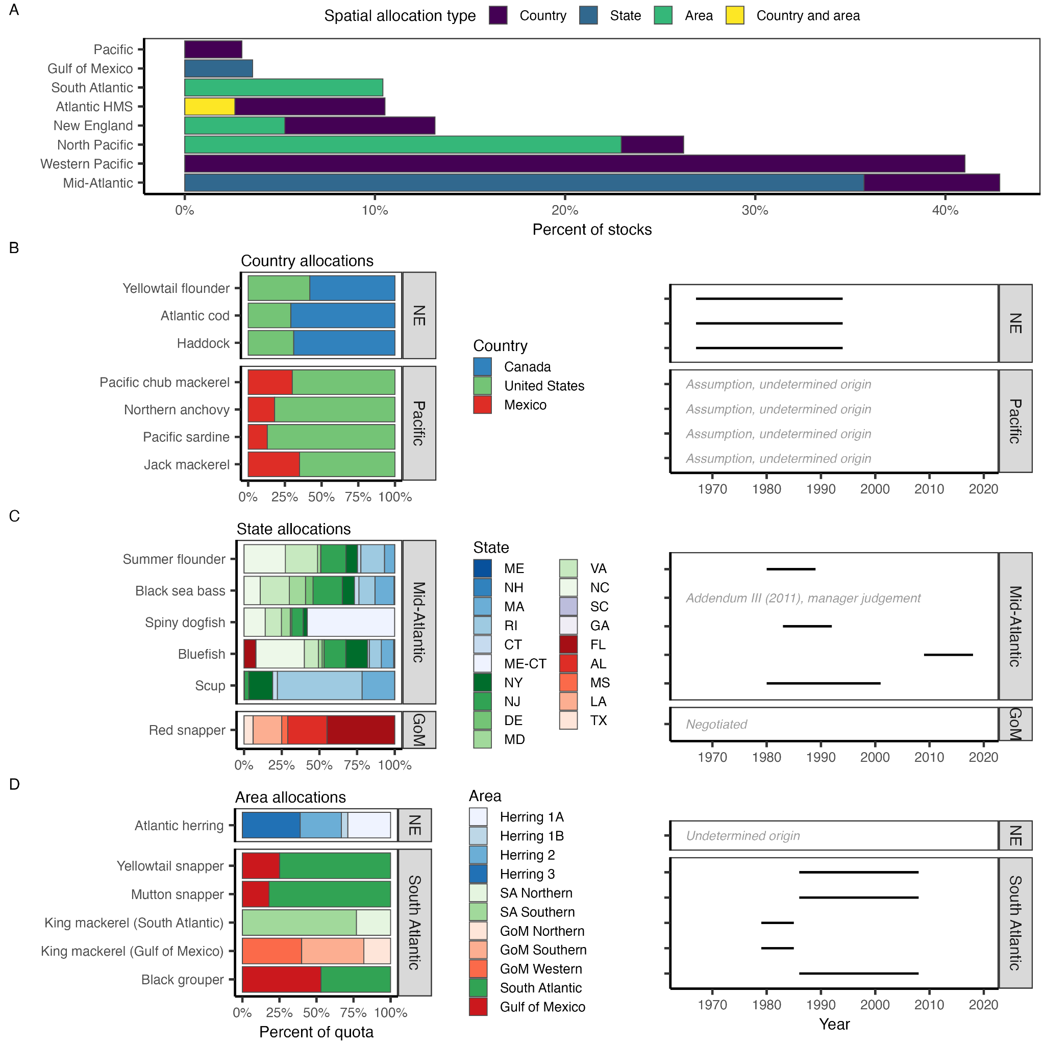

***Figure 4.*** *The (A) percent of stocks managed with spatial allocation policies by regional Fishery Management Council (FMC) and spatial allocation type and the percent allocations for stocks managed with (B) country-, (C) state-, and (D) area-based spatial allocation policies. In (C), color groups indicate the FMC representing each state: New England (blues), Mid-Atlantic (greens), South Atlantic (purples), and Gulf of Mexico (reds). In (D), color groups indicate the area scheme: herring zones (blues), South Atlantic king mackerel zones (greens), and Gulf of Mexico king mackerel zones (reds). The Atlantic bluefin tuna stock is managed by the Atlantic Highly Migratory Species (HMS) FMP using both country- and area-based spatial allocations.*

##### 2.2.3 Sector allocations

Sector allocations are used in the management of 27% (n=134 stocks) of federally managed stocks (**Figure 3**). The approach to allocating catch between commercial, recreational, tribal, and research sectors differs widely by region. In the South Atlantic, Gulf of Mexico, and Mid-Atlantic, which have the largest recreational fisheries of the eight management regions [(NMFS, 2022)](https://www.zotero.org/google-docs/?PxSodl) (**Figure 1**), allocations between commercial and recreational sectors are implemented as a fixed percentage of the total allowable catch, which is generally derived based on historical reference periods (**Figure 5AB**). The percentage and reference periods vary by region and stock. In the Caribbean, there are no explicit allocations of quota between commercial and recreational sectors, but the use of a constant catch harvest control rule [(Free, Mangin, et al., 2023)](https://www.zotero.org/google-docs/?RYquHI) represents an implicit allocation policy, as the allocation of catch remains fixed based on historical precedent (**Figure 5C**). In the remaining regions, allocations to the recreational fishery are largely done through “set asides”, which remove projections of the expected recreational catch from the total allowable catch and allocate the remainder to the commercial fishery. The only exceptions are for Gulf of Maine Atlantic cod (*Gadus morhua*, Gadidae) and haddock (*Melanogrammus aeglefinus*, Gadidae) in New England, which are allocated using fixed percentages (**Figure 5A**), and for Pacific salmon (*Oncorhynchus* spp., Salmonidae), which is allocated using policies that increase the percent allocation to recreational fisheries at low population sizes to ensure reasonable recreational fishing opportunities (**Figure 5D**). Allocations to tribal fisheries and research (e.g., bottom trawl surveys) are also done through set asides.

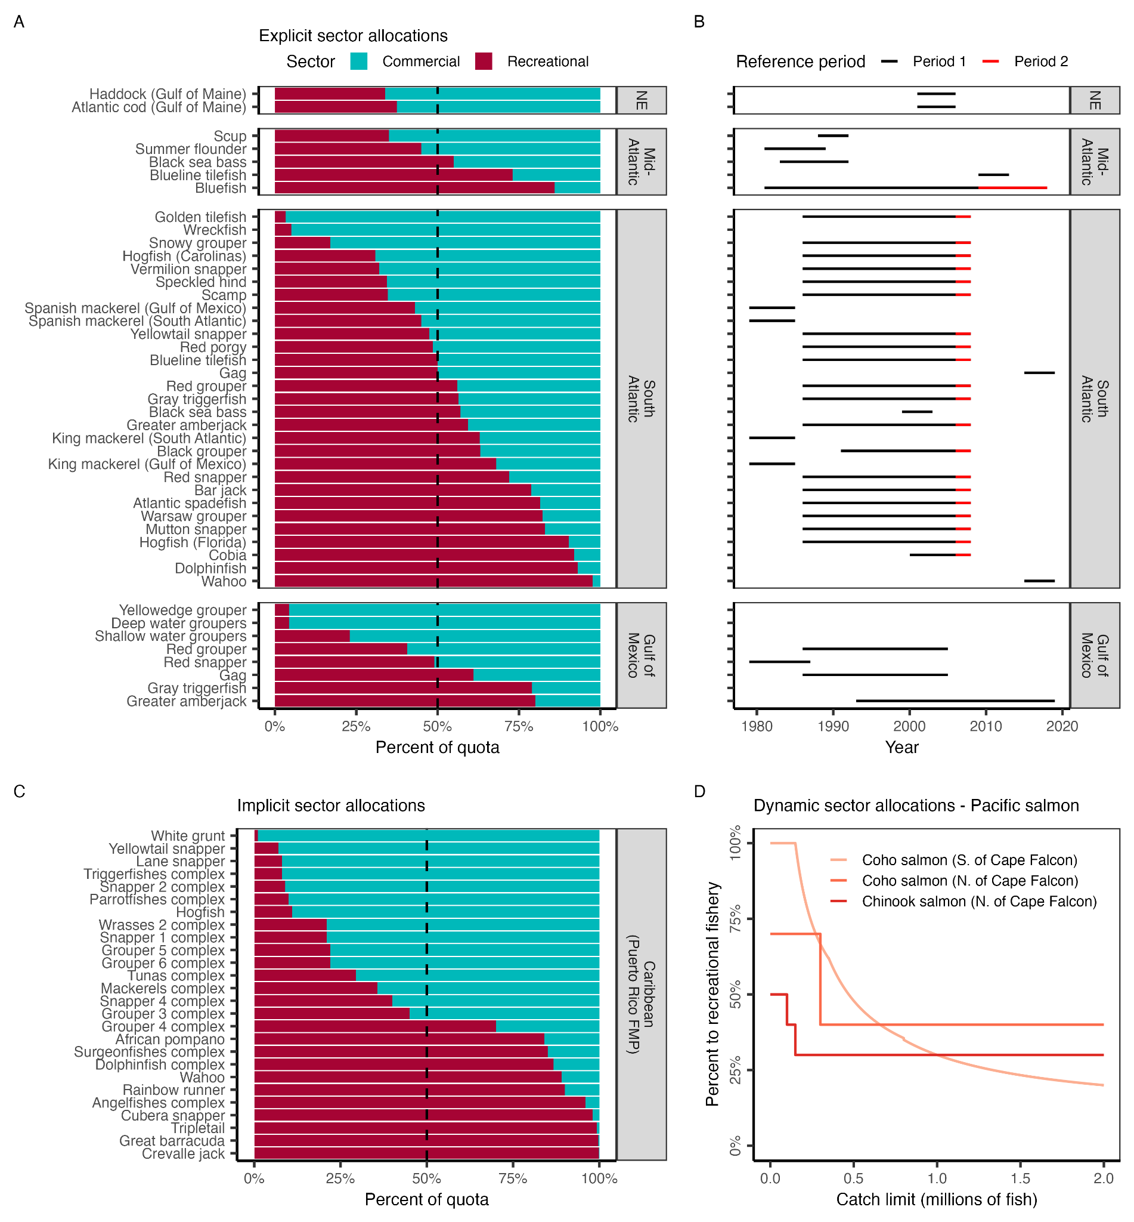

***Figure 5.*** *Sector-based allocation policies by regional Fishery Management Council (FMC). Panel* ***A*** *shows the percent of quota allocated to commercial and recreational fisheries by FMC and stock. Stocks are sorted in order of increasing allocations to recreational fisheries. The vertical dashed line indicates a 50:50 split. Panel* ***B*** *shows the reference period used to derive the allocation policy (lines). A few policies weigh the recent time period in addition to the selected reference time period. Panel* ***C*** *illustrates the implicit allocation policies resulting from setting fixed catch limits based on historical catch time series for stocks managed by the CFMC Puerto Rico FMP. Panel* ***D*** *shows the dynamic sector allocation policies used to vary sector allocations based on salmon stock size for stocks managed by the PFMC Pacific Salmon FMP.*

##### 2.2.4 Subsector allocations

Subsector allocations are used in the management of 15% (n=73 stocks) of federally managed stocks (**Figure 3**). They are especially widely used in the New England, North Pacific, and Pacific regions, which support a multitude of different fleets targeting diverse groundfish species (**Figures 3 & 6**). They are not used in the Western Pacific or Caribbean, potentially as a result of insufficient fleet-specific catch data. Subsector allocations are overwhelmingly used to divide catch within the commercial fishing sector (**Figure 6A**). Gulf of Mexico red snapper (*Lutjanus campechanus*, Lutjanidae), which allocates recreational catch between the for-hire (a.k.a., party boat, head boat, charter boat, 42.3%) and private fleets (57.7%), is the only stock managed using subsector allocations within the recreational sector. Commercial quota for Gulf of Alaska Pacific cod (*Gadus macrocephalus*, Gadidae) is divided between fifteen subsectors, the maximum number of divisions of any subsector-based allocation policy (**Figure 6B**). Within the commercial sector, subsector allocations are divided between fleets that differ in their: catch share program participation (16 stocks), gear type (e.g., longline, gillnet, trap; 16 stocks), end use of catch (e.g., bait or food; 6 stocks), target species (e.g., herring, non-herring; 3 stocks), and vessel tier (e.g., specialists vs. generalists; 2 stocks) (**Figure 6A**). Atlantic mackerel (*Scomber scombrus*, Scombridae) and golden tilefish (*Lopholatilus chamaeleonticeps*, Malacanthidae), both managed by the Mid-Atlantic FMC, are the only stocks for which quota is allocated among vessels exhibiting different “tiers” of participation or specialization in the fishery. The Northeast Skate Complex FMP, implemented in New England, allocates catch among vessels targeting skates for bait or for human consumption (“wing” fishery), and is the only FMP to allocate based on end use. The Northeast Multispecies FMP, also implemented in New England, is the only FMP to allocate catch among commercial fleets that do or do not participate in a catch share program.

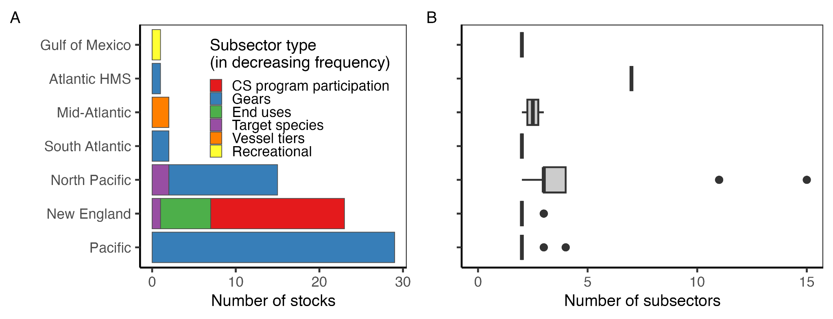

***Figure 6.*** *The (A) number of stocks managed using subsector allocations by regional Fishery Management Council (FMC) and subsector type and (B) number of subsectors included within the subsector allocation policies implemented by each FMC. In (A), all but the “Recreational” subsector type are commercial subsectors. In the boxplots, the solid line indicates the median, the box indicates the interquartile range (IQR; 25th to 75th percentiles), the whiskers indicate 1.5 times the IQR, and points indicate outliers.*

##### 2.2.5 Catch share allocations

Catch shares are used in the management of 23% (n=111 stocks) of federally managed stocks (**Figure 3**). There are currently 18 catch share programs for federally managed species in the U.S. The first program (Mid-Atlantic: Surf Clam and Ocean Quahog) was implemented in 1990, and the most recent (North Pacific: Pacific Cod Trawl Cooperative Program) in 2024 (**Table 1**). Additionally, in 2000, scallop permit holders in Alaska formed a self-organized, voluntary catch share that is managed through the Weathervane Scallop Cooperative that we include in our analyses. Catch shares are most common in the North Pacific. Currently, neither the Caribbean nor the Western Pacific implement any catch share programs. Initial allocations are typically distributed to active participants in the fishery at the time of program implementation, and are based on best years of landings during a historical reference period (**Figure 7**). However, alternative allocation procedures exist. For example, the Atlantic Sea Scallops IFQ bases allocations on historical landings and vessel size. In the case of the voluntary scallop cooperative program in Alaska, allocations are negotiated on a yearly basis by participants. For highly self-regulated programs such as AI Pollock and Alaska CDQ, allocations are also negotiated internally. In some programs, participants transfer individual allowance (quota, catch history, etc.) to cooperatives or sectors (e.g., “potential sector contribution” for New England Multispecies) on either a mandatory or voluntary basis. Some programs, including the Bering Sea and Aleutian Islands Non-Pollock (Amendment 80) Cooperative Program and the U.S. Atlantic Bluefin Tuna Longline Individual Bluefin Quota Program, were implemented to manage bycatch of non-target species in a fishery.

Many of the catch share programs in the U.S. share characteristics common to these types of programs. New entrants are uncommon because of the high cost of entry (e.g., cost of buying or leasing quota on top of cost of vessel, gear, gas, etc.). Currently, most programs allow transfers of both quota shares (permanent sale) and annual allocations (temporary lease) among entities. However, quota share caps (holdings cap) and annual allocation caps (use caps) are commonly implemented to limit consolidation [(Brinson & Thunberg, 2016)](https://www.zotero.org/google-docs/?zHShmt). Transfers can act as a mechanism for entry to a fishery, but quota is often too expensive for this to be feasible for early career fishermen [(Holland et al., 2017)](https://www.zotero.org/google-docs/?NfR65t). To combat this obstacle, programs such as the Gulf of Alaska’s Halibut and Sablefish IFQ’s Community Quota Entities rely on non-profits to buy quota, and lease it to community members, although these programs tend to be underutilized [(Soliman, 2015)](https://www.zotero.org/google-docs/?hxySYa). Although uncommon, adaptive catch share programs aim to ensure allocation is representative of species distributions and fishery activity, facilitate new entries, and reduce the prevalence of absentee quota owners [(Stephen et al., 2019)](https://www.zotero.org/google-docs/?vjsE30). For example, the West Coast Groundfish Trawl Catch Share Program sets aside 10% of quota to address issues common to catch share programs, but this reserve has consistently been passed-through to IFQ participants because the Pacific FMC has not yet identified ways to address issues with the set-aside quota [(NOAA, 2014)](https://www.zotero.org/google-docs/?9ygkOE). Adaptive catch share programs can also allow management to reclaim and redistribute quota, which presents a potential mechanism for adaptively revising allocation policies to better achieve equity and fairness goals under climate change.

***Table 1.*** *Catch share programs by regional Fishery Management Council (FMC).*

|  |  |
| --- | --- |
| **Program** | **Year** |
| *Atlantic HMS* |  |
| Individual Bluefin Tuna Quota | 2015 |
| *New England* |  |
| Atlantic Sea Scallops IFQ | 2010 |
| New England Multispecies Sectoris | 2010 |
| *Mid-Atlantic* |  |
| Surf Clam and Ocean Quahog | 1990 |
| Golden Tilefish | 2009 |
| *South Atlantic* |  |
| Wreckfish | 1991 |
| *Gulf of Mexico* |  |
| Red Snapper | 2007 |
| Grouper and Tilefish | 2010 |
| *Pacific* |  |
| Pacific Sablefish Permit Stacking | 2001 |
| West Coast Grounfish Trawl Rationalization | 2011 |
| *North Pacific* |  |
| Western Alaska Community Development Quota Program | 1992 |
| Individual Fishing Quota Halibut and Sablefish | 1995 |
| Bering Sea AFA Pollock Cooperative | 1999 |
| Weathervane Scallop Cooperative* | 2000 |
| Bering Sea and Aleutian Islands King and Tanner Crab | 2005 |
| Aleutian Islands Pollock | 2005 |
| Bering Sea and Aleutian Islands Groundfish (Non-Pollock) Cooperatives - Amendment 80 | 2008 |
| Central Gulf of Alaska Rockfish | 2011 |
| Pacific Cod Trawl Cooperative Program | 2024 |

* The Weathervane Scallop Cooperative is a voluntary program and is not listed on the NOAA Catch Share website (<https://www.fisheries.noaa.gov/national/sustainable-fisheries/catch-shares>). Our inclusion of this program and the recently added Pacific Cod Trawl Cooperative Program is why we arrive at 19 rather than 17 catch share programs.

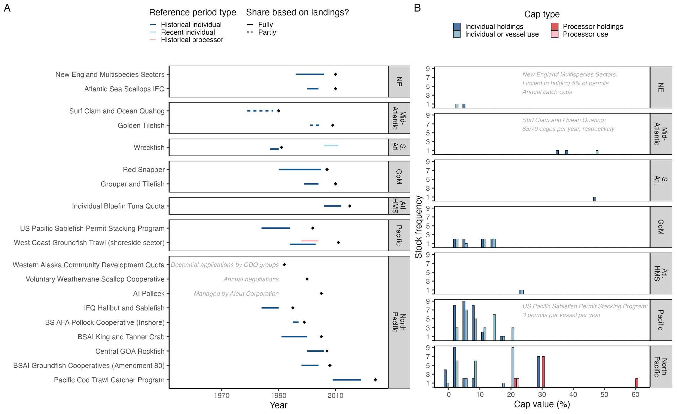

***Figure 7.*** *The (A) reference period and year of implementation (diamond) for allocations by program and regional Fishery Management Council (FMC) and (B) stock frequency distribution of holding and use caps by FMC. In (A) reference periods are colored by type (historical vs. recent, individual vs. processor). Programs with reference periods are sorted by implementation year. In 2012, inactive wreckfish quota was redistributed using a recent reference period (light blue). Dashed lines highlight programs in which shares are partly rather than fully based on landings (for Golden Tilefish, also depends on tier; for Surf Clam and Quahog, also depends on vessel size). Gray text explains protocol for programs that do not use landings to determine shares. Reference period can vary by species (New England Multispecies) and permit (Pacific Cod Trawl Catcher Program), therefore most common reference period is illustrated. In (B) cap value frequencies are colored by cap type (holding vs. use, individual vs. processor). Protocol for programs with non percent-based caps described in gray text. Crew, catcher/processor, and cooperative caps are rare and therefore excluded. The Weathervane Scallop Cooperative, W. AK Community Development Quota, and AI Pollock do not employ caps, and are therefore excluded. Halibut is excluded from IFQ Halibut and Sablefish because it is managed by the International Pacific Halibut Commission. Bars are offset by 3 when necessary for visualization.*

##### 2.2.6 Seasonal allocations

Seasonal quota allocations are only used to manage 7% (n=34 stocks) of federally managed stocks (**Figure 8**). In general, seasonal allocations are used to avoid catch limit overages and to curb the race to fish. A notable exception is the seasonal allocation policy for Atlantic herring (*Clupea harengus*, Clupeidae), which is used to ensure that the majority of catch comes when the demand for bait for the American lobster (*Homarus americanus*, Nephropidae) fishery is highest and the herring fishery is therefore most profitable. The Atlantic herring allocation policy is also noteworthy because of its flexibility, which makes it climate-adaptive. The policy is determined annually and can be allocated across bi-monthly, trimester, or seasonal periods based on the recommendations of constituent states. Seasonal allocations are most common on the U.S. East Coast (**Figure 8**). On the West Coast, they are only used for Pacific sardine (*Sardinops sagax*, Alosidae) and select species managed by the Bering Sea-Aleutian Island and Gulf of Alaska Groundfish FMPs (not illustrated; percents unknown). Existing seasonal allocations are divided among quarters (e.g., New England silver and red hake), trimesters (e.g., Mid-Atlantic longfin inshore squid), or seasons (e.g., South Atlantic king mackerel) (**Figure 8**).

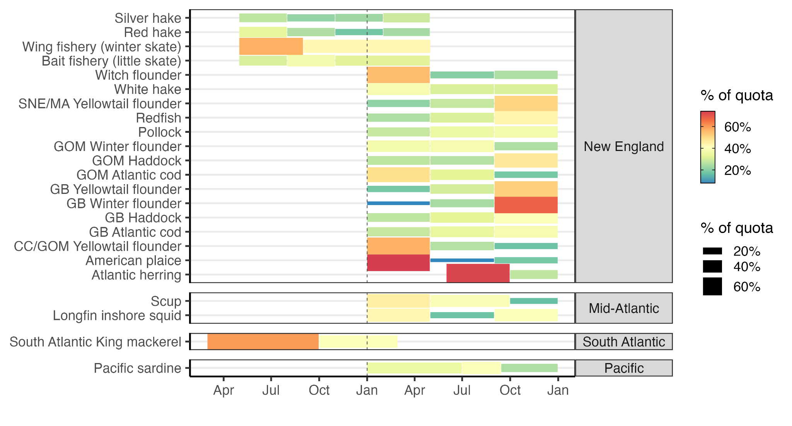

***Figure 8.*** *Seasonal allocations of stocks by regional Fishery Management Council. Blocks indicate the temporal extent of each season and block size and color indicate the percent of quota allocated to that season.*

### 3. Allocation policies in international fisheries

To broaden our search for climate-adaptive quota allocation policies, we supplemented our systematic review of allocation policies used in U.S. federal fisheries management with a brief review of allocation policies used in other fisheries around the world. The following section provides a brief overview of the quota allocation policies used in two countries and one international fishery whose allocation policies have been well summarized in a single source (i.e., an exhaustive review is not required to generate a comprehensive understanding of each entity’s allocation policies). The selected vignettes and their key references are as follows: Australia [(Knuckey et al., 2019; Mazur et al., 2020; McShane et al., 2021)](https://www.zotero.org/google-docs/?Ntcx9h), New Zealand [(Lock & Leslie, 2007)](https://www.zotero.org/google-docs/?Wjxczp), and the Parties to the Nauru Agreement (PNA) for Pacific skipjack tuna (*Katsuwonus pelamis*, Scombridae) [(Aqorau et al., 2018)](https://www.zotero.org/google-docs/?8VRcab). The successes and failures of these allocation policies are highly instructive to the U.S. and any other country that allocates quota.

#### 3.1 Australia

Australian allocation policies vary widely across subnational jurisdictions (states and territories). In 2010, the Australian Fisheries Managers Forum identified allocation as one the most important policy issues to address [(AFMF, 2010)](https://www.zotero.org/google-docs/?qeXyAv). In response, the Fisheries Research and Development Corporation formed a working group to synthesize existing allocation policies and provide recommendations for reform [(FRDC, 2012)](https://www.zotero.org/google-docs/?ydkHnI). The working group report found that all jurisdictions except Western Australia and South Australia lacked clear policies for guiding allocation decisions [(Neville, 2012)](https://www.zotero.org/google-docs/?u0TW9a). In 2016, another government report concluded that *“the basis for allocation is often opaque, uncertain, and/or of questionable efficiency”* and that *“stated policy objectives include multiple and sometimes competing goals that often provide limited guidance on how judgements should be made”* [(Productivity Commission, 2016)](https://www.zotero.org/google-docs/?IS3btB). Since these reports, Queensland, New South Wales, and Northern Territory have written allocation policies but have yet to implement them. Victoria and Tasmania have yet to write an allocation policy [(Knuckey et al., 2019)](https://www.zotero.org/google-docs/?xS12x6). In Western Australia and South Australia, sector allocations are made between commercial, recreational, and Indigenous fleets, and have largely been set based on historical catch, despite the fact that these allocation plans recognize the importance of social, cultural, and economic values in making allocation decisions [(Smyth et al., 2018)](https://www.zotero.org/google-docs/?Zf2Yly). A lack of data on Indigenous catch has led to a default allocation of 1% to Indigenous fishermen for most fisheries with sector allocations, which is analogous to the “*de minimis*” allocations employed by the U.S. Mid-Atlantic FMC. However, the South Australia management plan for Goolwa pipi (*Latona deltoides,* Donacidae), a small saltwater clam, allows for trading between sectors, and the Indigenous allocation has reached as high as 25% of the catch. A 2021 review of all Australian allocation policies found no examples of subsector allocations, which it described as being difficult to implement due to its controversial political nature [(McShane et al., 2021)](https://www.zotero.org/google-docs/?OCZFpq). In several jurisdictions, panels of independent experts and fishing industry representatives are convened to make or adjust allocation policies [(Mazur et al., 2020)](https://www.zotero.org/google-docs/?TU5kG2). These reviews can be triggered when there is sufficient stakeholder feedback, when a sector exceeds its allocation, or when the management plan is reviewed or changed substantially. If the panel determines a review is necessary based on the collected evidence, which includes information on historical catch, current allocation and management practices, and species biology, the panel makes recommendations to the minister of the relevant department, who makes the ultimate decision. This process is similar to NOAA guidelines for U.S. allocation policy reviews [(W. Morrison, 2016a, 2017b)](https://www.zotero.org/google-docs/?noh3PF), except for its use of an independent panel to make unbiased judgements.

#### 3.2 New Zealand

The majority of New Zealand’s harvested marine species are managed through the Quota Management System (QMS), which is the national program under which catch limits are set and allocated between commercial, recreational, and customary fishery sectors [(Lock & Leslie, 2007)](https://www.zotero.org/google-docs/?i9vUxN). Customary fisheries are managed by *tangata whenua* (people of the land with authority in a particular *rohe moana* [fishing area]) for non-commercial food gathering and were secured by the Treaty of Waitangi (Fisheries Claims) Settlement Act 1992. The allocation between sectors varies by species [(Fisheries of New Zealand, 2024a)](https://www.zotero.org/google-docs/?3FS72K) but is generally dominated by the commercial sector (**Figure 9**). Within the commercial sector, quota is allocated among commercial fishers that individually own Annual Catch Entitlements (ACEs) in the QMS catch share system. ACEs may be sold or leased, but there are species-specific maximum holding limits to curtail aggregation, diversify ownership, and promote pathways for entering the fishery. There are also minimum holdings limits [(Fisheries of New Zealand, 2024b)](https://www.zotero.org/google-docs/?WjAcAT), which are presumably used to reduce complexity, increase attainment, and/or encourage stewardship, though we cannot find a stated motivation for these limits. Initial allocations were made based on each vessel owner’s catch history (i.e., owner’s choice of catch from the 1981/82, 82/83, or 83/84 season) and negotiations through a complex appeal process. When first introduced in 1986, these allocations were made as a fixed tonnage based on the Government’s misguided belief that catch limits would only increase with improved management [(Lock & Leslie, 2007)](https://www.zotero.org/google-docs/?ItRMWH). However, in 1990, the near collapse of the orange roughy (*Hoplostethus atlanticus*, Trachichthyidae) fishery led the Government to convert shares to a fixed proportion, based on quota owners holdings at the time of the transition. In the interim years, the Government bought back surplus quota when the sum of quota exceeded the catch limit, which was predictably expensive and inefficient. The Māori, the indigenous people of New Zealand, were excluded from the initial commercial quota allocation process. The 1996 Fisheries Act determined that the Māori would be allocated 20% of the commercial quota for all new species added to the QMS and the remainder would be allocated to fishing permit holders based on their catch history. In 2022, the Māori were reported to own 33% of commercial quota (47% by value) and 100% of the customary quota [(Hudson, 2022)](https://www.zotero.org/google-docs/?9OGYdn).

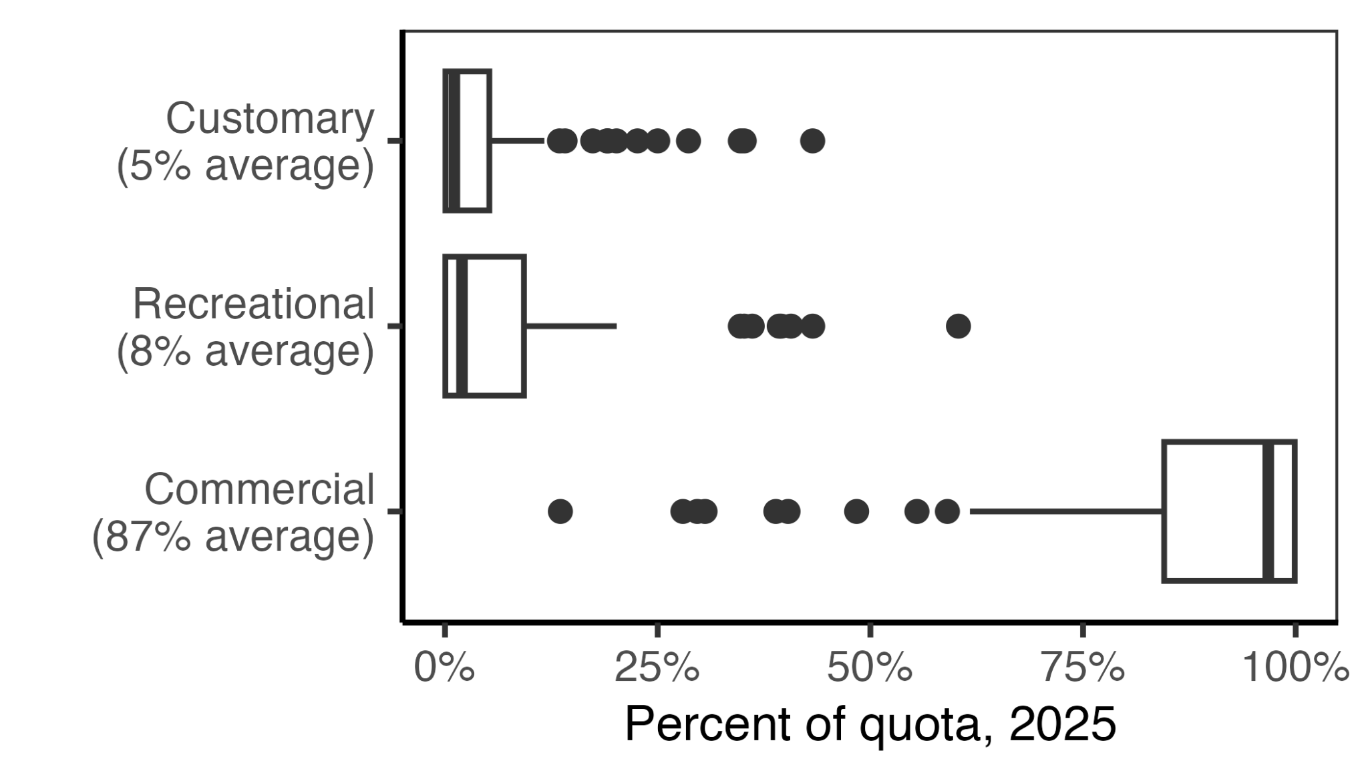

***Figure 9.*** *Quota allocation percentages among sectors for the 98 species managed within New Zealand’s Quota Management System in 2025* [*(Fisheries of New Zealand, 2024a)*](https://www.zotero.org/google-docs/?NNXLkC)*. In the boxplots, the solid line indicates the median, the box indicates the interquartile range (IQR; 25th to 75th percentiles), the whiskers indicate 1.5 times the IQR, and points indicate outliers.*

#### 3.3 Pacific Island skipjack tuna

The Parties to the Nauru Agreement (PNA) [(PNA Tuna, 2010)](https://www.zotero.org/google-docs/?FKhFpp), which governs the management of skipjack tuna (*Katsuwonus pelamis*, Scombridae) in nine Pacific Island countries, has been heralded as one of the best climate-adaptive spatial allocation systems [(Aqorau et al., 2018)](https://www.zotero.org/google-docs/?W7pX9F). The PNA’s “vessel day scheme” (VDS) [(PNA Tuna, 2011)](https://www.zotero.org/google-docs/?pmAXlQ) was explicitly developed to cooperatively manage this highly migratory species as it shifts its distribution across the waters of PNA members due to changing oceanographic conditions. The VDS is a “cap and trade” system that sets the total annual purse-seine fishing effort at ~45,000 days and allocates these days to member countries based on the area of their Exclusive Economic Zones (EEZs) and the preceding 7-8 years of catch. Importantly, the VDS also provides a pathway for PNA members to trade quota in response to El Niño Southern Oscillation (ENSO). During the La Niña phase of ENSO, the catch is concentrated in the west, whereas during the El Niño phase, the catch is concentrated in the east [(Lehodey et al., 1997)](https://www.zotero.org/google-docs/?h4x4Js). With trading, the VDS allows countries to purchase fishing days when tuna are located in their region and sell fishing days when tuna are located elsewhere. In this way, the VDS allows member countries to profit regardless of where skipjack tuna are caught that year. This system is expected to provide community resilience as skipjack tuna shift east due to directional climate change [(Bell et al., 2013)](https://www.zotero.org/google-docs/?KfK4gG). The expectation is that, over time, PNA countries in the east will gradually receive greater allocations as their catch history increases relative to countries in the west, and countries in the west will be compensated for these directional losses through the annual leasing of their remaining allocation [(Aqorau et al., 2018)](https://www.zotero.org/google-docs/?J6eAp6).

### 4. Best practices for climate-adaptive allocation policies

Based on our systematic review of U.S. allocation policies and informal review of international policies and the scientific literature, we identified eight best practices for implementing or enhancing the adaptive management of quota allocation policies (**Figure 10**). Adaptive management, which periodically reviews and updates management strategies to ensure that management objectives are being met [(Walters & Hilborn, 1976)](https://www.zotero.org/google-docs/?FCH2ZC), provides inherent climate resilience by ensuring that management is responsive to changing conditions [(Bahri et al., 2021)](https://www.zotero.org/google-docs/?De7Wq7). These best practices are to: (1) define clear and measurable management objectives; (2) define and collect data required to assess and adjust allocation policies; (3) facilitate quota transfers between regions, sectors, and individuals; (4) balance historical and contemporary resource access in setting allocations; (5) ensure opportunities for new entrants; (6) allocate quota for research and experimentation; (7) reduce impacts of changes to allocation policies on stakeholders; and (8) conduct regular reviews of allocation policies. We detail these recommendations in the sections below.

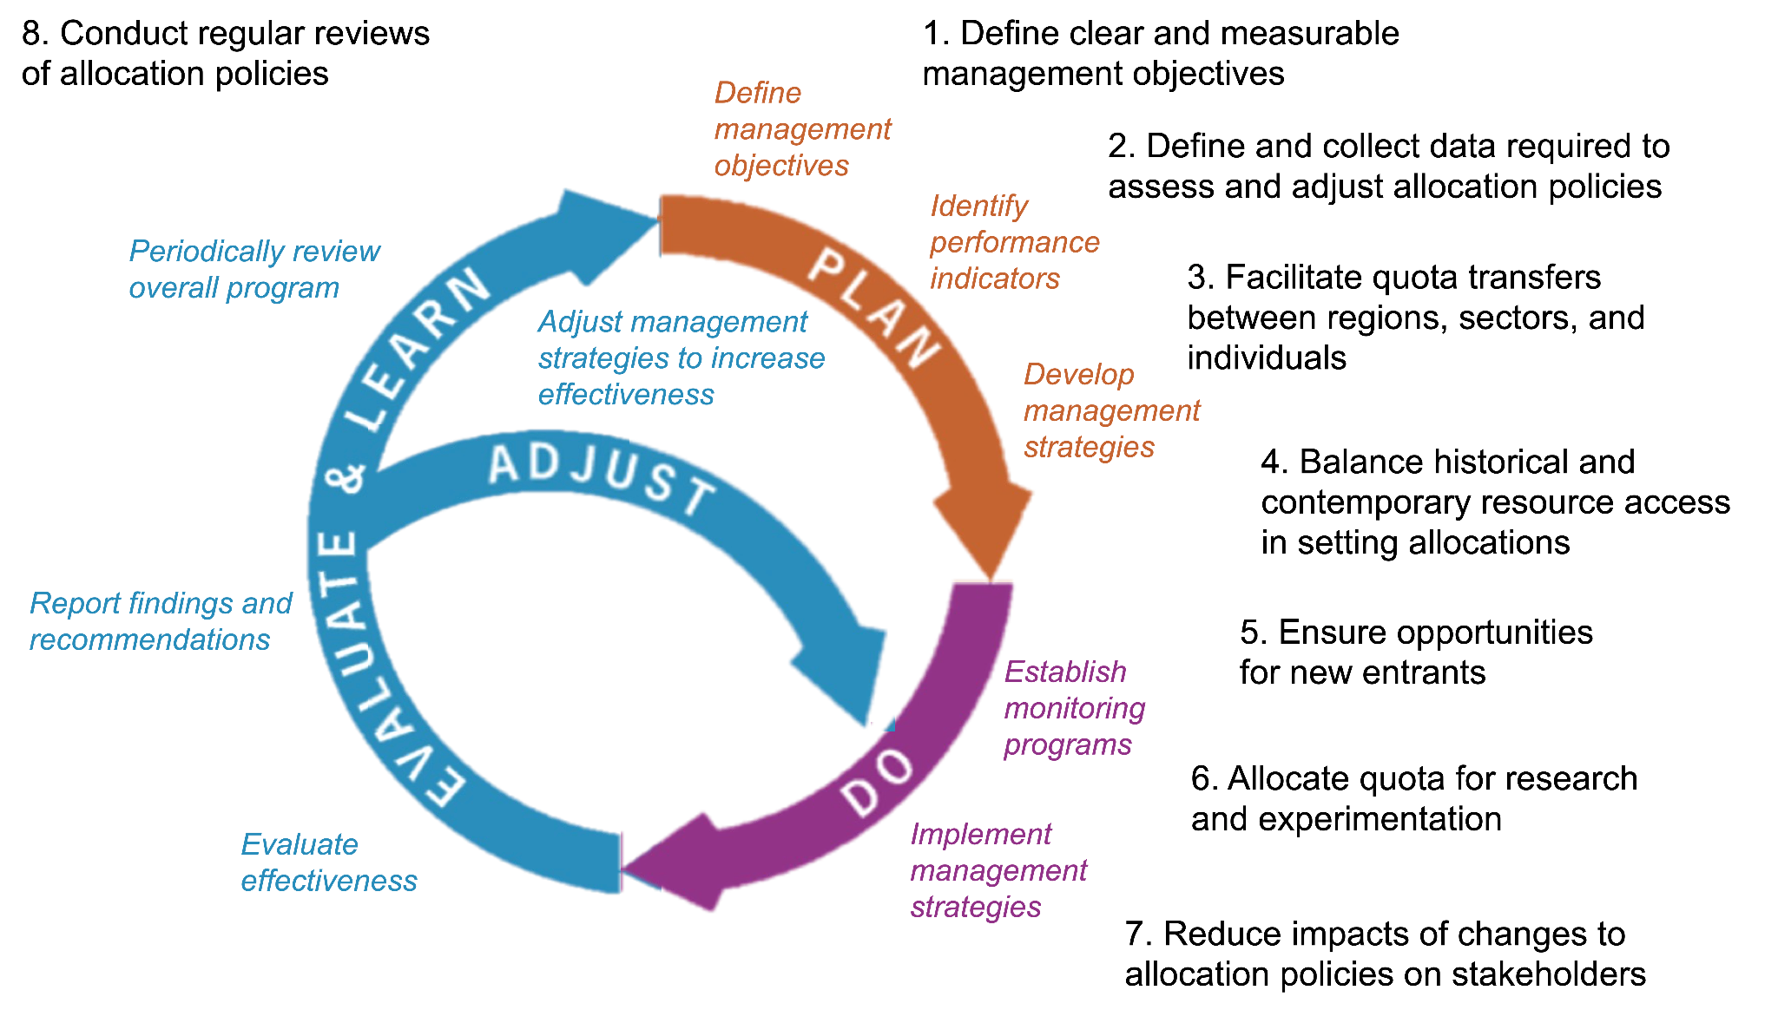***Figure 10.*** *A conceptual diagram illustrating the eight best practices (black text) for enhancing the adaptive management of quota allocation policies.*

#### 4.1 Define clear and measurable management objectives

The adaptive management of quota allocation policies depends on the definition of clear and measurable management objectives [(Plummer et al., 2012)](https://www.zotero.org/google-docs/?iD9epm). Without these, managers will be unable to track whether objectives are being met or determine if adjustments are necessary, which is especially problematic as climate-driven changes in resource availability accelerate the need for policy modifications. We recommend that each FMP/FEP or other relevant policy document (e.g., catch share policy) define allocation objectives, discuss tradeoffs between competing objectives [(Heen et al., 2014; Mardle et al., 2000)](https://www.zotero.org/google-docs/?fRHQHr), and identify data sources that can be used to monitor progress towards the objectives (see *section 4.2* for more details). Adaptive management of allocation policies provides inherent climate resilience by ensuring that policies are regularly revisited to ensure that they are achieving their objectives as both oceanographic and socioeconomic conditions change. There may also be opportunities to explicitly incorporate climate change into allocation policy objectives. For example, allocation could be used as a tool for mitigating the negative impacts of climate change, especially on vulnerable communities, by allocating the most climate-vulnerable communities [(Colburn et al., 2016; Himes-Cornell & Kasperski, 2015; Koehn et al., 2022)](https://www.zotero.org/google-docs/?9XLhJ3) more quota than their historical share (**Figure 11C**). While allocations have historically sought to maintain “horizontal equity” where allocations are proportional to historical access (**Figure 11B**), the Magnuson-Stevens Act and associated guidelines leave the door open for alternative definitions of equity [(W. Morrison, 2016b)](https://www.zotero.org/google-docs/?30ZW58). For example, managers could set goals for “vertical equity” (**Figure 11C**) and use allocation as a tool for compensating communities disadvantaged by historical allocations or by the impacts of contemporary or future climate change [(Kourantidou et al., 2021)](https://www.zotero.org/google-docs/?FjcjKN).

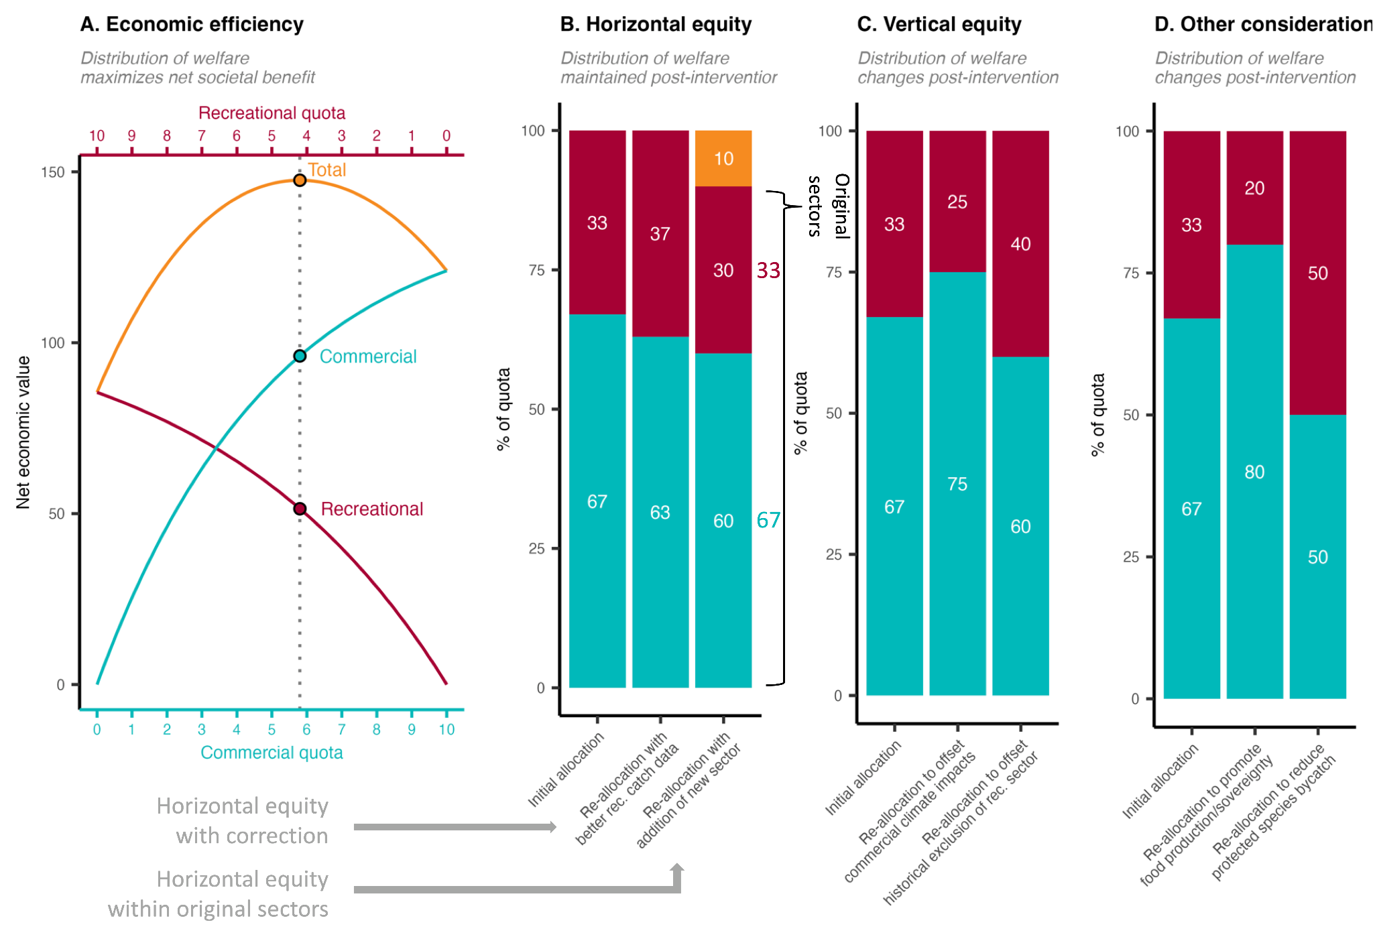

***Figure 11.*** *An illustration of alternative conceptualizations of equity in quota allocation policies. Panel* ***A*** *illustrates an allocation policy that seeks to optimize economic efficiency by maximizing the net economic benefits of commercial and recreational fisheries. The optimal policy is marked by the vertical dotted line. Panel* ***B*** *illustrates a suite of allocation policies that seek to maintain “horizontal equity” whereby the distribution of welfare remains proportional to historical levels. Column 1 shows the initial allocation based on historical catch. Column 2 illustrates a scenario in which the policy is updated with improved estimates of historical recreational catches. Although it results in a different distribution of welfare relative to the initial policy, it is motivated by the same goals (but uses better data) and is therefore still an example of horizontal equity. Column 3 illustrates a scenario in which a historically omitted subsistence sector (orange) is given access. The losses in allocation to the original sectors are proportional; thus, horizontal equity is maintained. Panel* ***C*** *illustrates a suite of allocation policies that seek to achieve “vertical equity” whereby the distribution of welfare changes after an intervention in a way considered more fair. This could be to compensate communities disadvantaged by historical allocations (column 2) or by the impacts of contemporary or future climate change (column 3). Panel* ***D*** *illustrates how managers could adjust allocation policies to achieve other fisheries objectives, such as promoting food production* *and sovereignty by prioritizing commercial fishing (column 2) or reducing bycatch of protected species by prioritizing more selective recreational fisheries (column 3). Although these adjustments change the distribution of welfare, they are not motivated by equity and fairness between sectors (though they do relate to broader societal concepts of fairness) and therefore do not qualify as vertical equity. We illustrate these concepts using sector allocations as an example, but all these concepts apply to any allocation between harvesting entities (states, subsectors, individuals, etc).*

#### 4.2 Define and collect data required to assess and adjust allocation policies

The adaptive management process hinges on the definition and evaluation of indicators for tracking management performance and for determining when adjustments need to be made to management strategies or even management objectives [(Walters, 2007)](https://www.zotero.org/google-docs/?MPKGbJ). This requires resources to be directed to data collection and analysis that can inform whether allocations are achieving their objectives and subsequently guide revisions if they are not. The following list of potential indicators is not comprehensive but illustrates some of the data types that could be useful for tracking performance. First, catch reporting and monitoring should be specific enough to evaluate attainment (i.e., the percent of the allocation caught annually) among the entities allocated catch. If rigorous catch monitoring is established and a specific entity (e.g., state, sector, subsector, etc.) is consistently under its quota, then reallocation of that quota to another entity, especially if that entity consistently meets its quota, may be justified. Second, reliable estimates of recreational catch, which is notoriously challenging to quantify, and well-designed and well-supported survey methods [(National Academy, 2006)](https://www.zotero.org/google-docs/?xooIP0) are necessary to ensure fair access for this sector [(Ryan et al., 2016)](https://www.zotero.org/google-docs/?fngPA8). Third, reliable estimates of discards may be necessary to determine whether the current allocation is using the resource efficiently and minimizing waste and ecosystem impacts. Fourth, demographic information on fishery participants throughout the supply chain – ranging from owners, captains, crew, processors, and dealers – especially on vulnerable groups, is necessary for evaluating equity and fairness [(NAS, 2024)](https://www.zotero.org/google-docs/?DkkTmi). Fifth, knowledge of species distributions, which may require coordination across states, FMCs, and even nations, will involve collection, curation, and analysis of fisheries-independent survey data (see DisMAP as example; [(NOAA Fisheries, 2024a)](https://www.zotero.org/google-docs/?BzdG6D)). Sixth, regional Climate Vulnerability Assessments [(W. E. Morrison et al., 2015, 2016; NOAA Fisheries, 2024b)](https://www.zotero.org/google-docs/?dtt71B) should be revisited to ensure the inclusion of all federally managed species (**Figure 13**) to better support the consideration of climate vulnerability in allocation decisions. Finally, to effectively consider habitat impacts of a gear, protected species bycatch, or other factors in making allocations, data must be collected to inform these judgements. Ultimately, the data collected should be aligned with management objectives; a management objective may prove ineffective if it is not measurable or is not actively measured.

#### 4.3 Facilitate quota transfers between regions, sectors, and individuals

The ability for quota owners to transfer quota access rights – either temporarily through leasing or permanently through sale – provides flexibility for fishermen to adapt to climate change and other shocks [(Tokunaga et al., 2023)](https://www.zotero.org/google-docs/?yBsAze). The temporary transfer of quota access through leasing provides in-season flexibility and the ability for fishermen to rapidly respond to changes in ways that are more self-governed. The permanent transfer of quota access provides a mechanism for fishermen who have lost access to a resource to be compensated and provides capital necessary for adapting to this loss of livelihood provisioning. While the ability to transfer quota between individuals is a feature of most catch share programs, the ability to transfer quota between states, sectors, and subsectors is less common, which presents a key opportunity to enhance climate resilience. As one example, limited ability to transfer or lease quota between the at-sea and inshore Bering Sea pollock (*Gadus chalcogrammus*, Gadidae) sector have limited the fisheries ability to respond to changes in species distributions, bycatch management, and market dynamics [(Criddle & Strong, 2013)](https://www.zotero.org/google-docs/?t4sSrC). These programs could be modeled after Mid-Atlantic bluefish (*Pomatomus saltatrix*, Pomatomidae), which allows for in-season transfers between the commercial and recreational sectors and between states, and Mid-Atlantic black sea bass (*Centropristis striata*, Serranidae) and summer flounder (*Paralichthys dentatus*, Paralichthyidae), which also allows for transfers between states. In catch share programs, a key risk in allowing transfers is the consolidation of quota among a few individual entities, some of which may no longer actively fish or even reside in the community; however, this adverse outcome can be curbed through the use of allocation caps that limit the percent of quota that can be possessed or used by an individual entity [(Brinson & Thunberg, 2016)](https://www.zotero.org/google-docs/?0idAfu). This is consistent with National Standard 4, which requires that “*no particular individual, corporation, or other entity acquires an excessive share of such privileges”* [(§ 600.325 National Standard 4—Allocations, 1998)](https://www.zotero.org/google-docs/?2yFL8n). The transferability of quota also serves to: (1) increase economic efficiency, by ensuring that quota aggregates among those with easiest access to the resource; (2) promote conservation, by ensuring that fishing effort occurs in proportion to biomass, thereby avoiding the local depletion that could occur if quota remained tied to areas with declining abundance [(Pinsky & Fogarty, 2012)](https://www.zotero.org/google-docs/?fQOrKn); and (3) provide a mechanism for fishermen losing access to be directly compensated and for fishermen gaining access to capitalize on emerging resources, which could compensate for climate-driven losses in other fisheries in their portfolio [(Cline et al., 2017; Samhouri et al., 2024)](https://www.zotero.org/google-docs/?vRg4tj). Finally, the ability to transfer quota is aligned with resilience principles that encourage self-governance and flexibility [(Mason et al., 2022)](https://www.zotero.org/google-docs/?VSN1dp).

#### 4.4 Balance historical and contemporary resource access in setting allocations

The adaptation of allocation policies to climate-driven changes in resource distribution will require weighing both historical and contemporary access to resources **(Figure 12**). The tendency for current allocation policies to interpret equity as the maintenance of historical access is unlikely to meet fisheries objectives as stocks shift in their availability. A failure to adjust allocations in response to these shifts could undermine (1) fairness and equity, by preventing those with growing local fisheries from benefiting from these gains, (2) efficiency, by requiring vessels to travel further to access the resource, which increases costs, safety concerns, and carbon emissions [(Papaioannou et al., 2021; Scherrer et al., 2024)](https://www.zotero.org/google-docs/?5CpIwu); and (3) conservation, by promoting local depletion if quota holders continue to fish in areas at the trailing edge of a shifting distribution [(Pinsky & Fogarty, 2012)](https://www.zotero.org/google-docs/?LqCJwN). However, at the other end of the spectrum, fully adjusting allocation policies in response to contemporary or projected changes in resource distributions could also introduce fairness and equity challenges by reducing access for stakeholders who have historically relied on the resource [(Palacios-Abrantes et al., 2023)](https://www.zotero.org/google-docs/?MbCxMl). Thus, adjusting allocations by weighing both historical and contemporary resource access may present a useful compromise, especially when quota is transferable (see *section 4.3*). This can be achieved by calculating allocation percentages by weighing historical landings with recent landings (e.g., sector allocations in the South Atlantic snapper-grouper fishery) or with current biomass distribution as estimated from either a survey (e.g., area allocations in the Gulf of Alaska pollock fishery) or an assessment model (e.g., state allocations in the Mid-Atlantic black sea bass commercial fishery). Among these approaches, we recommend weighing current conditions based on the distribution of the resource, as the distribution of the catch lags behind resource shifts and is inherently limited by existing allocation policies and management regulations [(Pinsky & Fogarty, 2012)](https://www.zotero.org/google-docs/?uGVe7Q). Additionally, we recommend quantifying distribution shifts using fisheries-independent surveys given the high temporal and spatial resolution of these surveys [(Maureaud et al., 2024)](https://www.zotero.org/google-docs/?kxPKU6) compared to stock assessments, which are updated less regularly (e.g., every 2-10 years; [(Neubauer et al., 2018)](https://www.zotero.org/google-docs/?yKE9Jp)) and represent coarse spatial structure. Ultimately, the weight assigned to historical and contemporary access is a policy decision that should be explicitly linked to policy objectives, but in general, we recommend that historical access be favored for static stocks and that contemporary access be favored for shifting stocks. In the Mid-Atlantic, scientists and managers have begun to explore the viability of an automated “dynamic allocation” procedure that uses both current distributions and historical catch to update allocations for shifting stocks without requiring renegotiations and time intensive FMP amendments [(Vogel et al., 2024)](https://www.zotero.org/google-docs/?pv16k3).

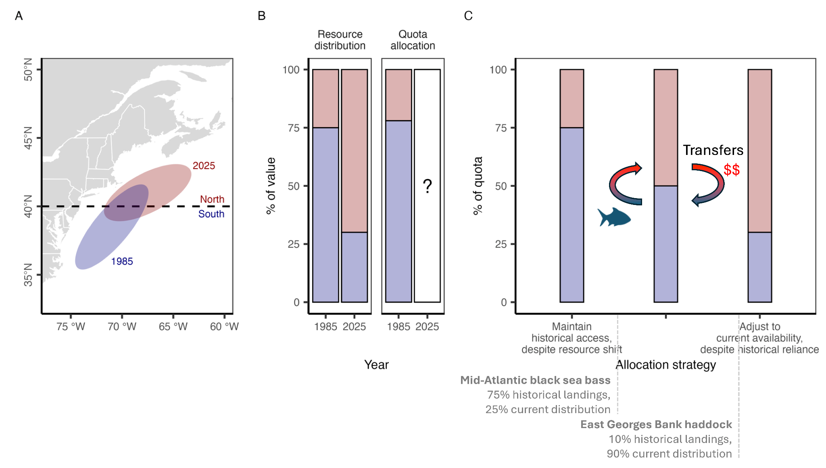

***Figure 12.*** *A conceptual schematic illustrating the spectrum of allocation options available to managers as stocks shift distributions and their availability to fisheries under climate change. Panel* ***A*** *illustrates the shift in distribution of hypothetical stock from 1985 to 2025 relative to a hypothetical management boundary. Panel* ***B*** *illustrates the proportional distribution of the resource between the two management zones in 1985 and 2025. The allocation of quota between the zones roughly matches the 1985 distribution because it was established based on 1980-1985 catch distribution. Managers must now decide whether and how to adjust the quota allocation given the climate-driven shift in distribution. Panel* ***C*** *illustrates the spectrum of options available to managers. On one end of the spectrum, managers could maintain historical access despite the resource shift. This protects historical access for southern zone fishermen but introduces inefficiencies, risks local depletion, and is unfair to northern zone fishermen. On the other end of the spectrum, managers could fully adjust to current resource distribution. This is efficient and aligned with conservation goals but does not protect historical dependence and is therefore unfair to southern fishermen. As a result, managers may wish to find a middle ground between these two extremes. Examples of allocation policies that fall in middleground are highlighted. Furthermore, allowing transfers between zones provides a mechanism for northern fishers to gain access and for southern fishers to be compensated for lost access.*

#### 4.5 Ensure opportunities for new entrants

Any policy that allocates natural resources among harvesters should consider new entrants seeking to gain access to the resource [(Cox, 2009)](https://www.zotero.org/google-docs/?hc6krS). The initial capital required to obtain commercial fishing permits, quota, gear, and/or vessels limits new participants [(Cullenberg et al., 2017)](https://www.zotero.org/google-docs/?JlN91p). These barriers are particularly steep in fisheries with catch shares or other forms of limited entry programs, and have played a role in the ‘graying of the fleet,’ or the increased average age of commercial fishermen [(Cramer et al., 2018)](https://www.zotero.org/google-docs/?xGh8RE). Climate change is likely to exacerbate the new entrant problem as climate-driven shifts in the distribution of fish and invertebrates will make the resource available to new regions, sectors, and individuals [(Pinsky et al., 2018)](https://www.zotero.org/google-docs/?oS5aBz). A pathway for providing access to these new participants is critical for increasing economic efficiency, perceptions of fairness, and the stability of allocation decisions [(Cox, 2009)](https://www.zotero.org/google-docs/?D8vDPF). Access for new entrants could be catalyzed through set asides reserved for new entrants or through quota and/or permit banks that ease access for new participants. For example, through the Adaptive Management Program (AMP; Amendment 20 of the Pacific Groundfish FMP) the Pacific FMC sets aside quota from the groundfish catch share program in a “public trust pool” that can be used to support conservation, new entrants, community stability, or to compensate for unintended consequences of the catch share program [(PFMC & NMFS, 2010)](https://www.zotero.org/google-docs/?OCXABC). Unfortunately, the program has yet to be used and instead AMP quota has been passed to fishermen in proportion with quota share holding, limiting insights into both the benefits and pitfalls of new entrant set asides [(Nayani & Warlick, 2018)](https://www.zotero.org/google-docs/?HOV4Lh). The leasing of quota or permits to new participants through fisheries trusts (banks), potentially at rates lower than they would receive from a traditional owner, can help new entrants gain experience and capital before buying quota or permits themselves [(Kauer et al., 2024)](https://www.zotero.org/google-docs/?CBUG8k). For example, in 2010, the Maine Department of Marine Resources purchased eleven federal Northeast Multispecies permits, which it leases to fishermen through the Maine Groundfish Permit Bank [(Maine DMR, 2022)](https://www.zotero.org/google-docs/?hqjimN). Other examples include the Alaska Community Quota Entities, which lease groundfish and crab quota to catch share members [(NPFMC, 2016)](https://www.zotero.org/google-docs/?QEAL8X) and the Monterey Bay Fisheries Trust, which leases groundfish quota at reduced rates to local fishermen [(Kauer et al., 2024)](https://www.zotero.org/google-docs/?B6pP12). Finally, quota transfers (see *section 4.3*) are a useful tool for fishermen seeking to expand their participation in an emerging fishery, which can enhance climate resilience if other fisheries in their portfolios are experiencing climate-driven declines [(Cline et al., 2017; Samhouri et al., 2024)](https://www.zotero.org/google-docs/?iR8SxI).

#### 4.6 Allocate quota for research and experimentation

The allocation of quota towards programs that support research and experimentation could incentivize adaptive innovation in response to climate change. This could include the reservation of quota for existing programs such as “research set asides” (RSAs) or for “exempted fishing permits” (EFPs). Research set asides, which have only been used by the New England and Mid-Atlantic FMCs, represent a portion of quota that is set aside for vessels engaged in scientific research. The set-aside quota is awarded through a competitive grant process and the sale of the associated catch both funds the research and compensates the vessels supporting the research [(NOAA, 2024)](https://www.zotero.org/google-docs/?0GOTq2). These programs have been especially successful for high value stocks such as Atlantic scallops (*Placopecten magellanicus*, Pectinidae) and monkfish (*Lophius americanus*, Lophiidae) in New England (Vogel et al. 2024), where they have supported innovative research on climate change and population dynamics, improved survey methods, and bycatch avoidance [(NOAA, 2024)](https://www.zotero.org/google-docs/?IZTm8p). The program in the Mid-Atlantic lasted from 2002-2014 and funded 41 projects totalling $16 million in value [(MAFMC, 2024)](https://www.zotero.org/google-docs/?FyFHjq) on issues ranging from black sea bass trap design to evaluations of summer flounder size and bag limits [(MAFMC, 2021b)](https://www.zotero.org/google-docs/?Wzzyte). The program was discontinued due to concerns of misuse (e.g., misreporting of landings) and concerns that the quality of the science did not justify the costs [(Seagraves, 2014)](https://www.zotero.org/google-docs/?MXjLKR). While some projects, such as the trawl survey conducted by the Northeast Area Monitoring and Assessment Program, generated data used in management, many other projects failed scientific review post-completion, raising concerns about proposal vetting and project oversight [(MAFMC, 2024)](https://www.zotero.org/google-docs/?bCB4li). Thus, expansion of the RSA program would require reforms that address these issues. Exempted fishing permits are a national program supported by all of the FMCs [(NMFS, 1996)](https://www.zotero.org/google-docs/?ce4y7t). These permits allow fishermen who partner with scientists to conduct cooperative research to fish in ways that may not otherwise be permitted. The dedicated allocation of quota to these programs could incentivize research into adaptive actions that promote climate resilience [(Bonito et al., 2022)](https://www.zotero.org/google-docs/?HLLaY1). For example, research could reveal methods for targeting emerging fisheries, avoiding bycatch problems, generating more reliable indices of abundance that support better management, marketing new products, or making gears more efficient [(Free, Anderson, et al., 2023)](https://www.zotero.org/google-docs/?b8198F).

#### 4.7 Reduce impacts of changes to allocation policies on stakeholders

The adjustment of quota allocation policies in response to climate change and other socioecological factors will inevitably result in a set of “winners” who gain quota and “losers” whose quota is taken away. A number of actions can be taken to minimize the socioeconomic impacts to individuals and communities losing access to quota when allocation policies change. First, the gradual “phase in” or “phase out” of changes to allocation policies provides time to adapt. Phased allocation changes have been pioneered by the Mid-Atlantic FMC, which, for example, used a 7-year phase-in period to reallocate commercial bluefish (*Pomatomus saltatrix*, Pomatomidae) quota among fourteen East Coast states [(MAFMC, 2021a)](https://www.zotero.org/google-docs/?9tCouD). Second, the preservation of some minimal amount of quota through a “*de minimis*” allocation guarantees at least some level of access for historical participants when allocations are dynamically updated based on the current abundance or distribution of resources. *De minimis* allocations have been used by the Mid-Atlantic FMC to preserve minimum levels of commercial access to bluefish by states [(MAFMC, 2021a)](https://www.zotero.org/google-docs/?ZLEIVy) and have been used by the Pacific FMC to preserve minimum levels of access to South of Cape Falcon Coho salmon (*Oncorhynchus kisutch*, Salmonidae) for the recreational sector when biomass fluctuates [(PFMC, 2021)](https://www.zotero.org/google-docs/?TtNNkT). Such policies could preserve access if the adjustment of spatial quota allocations in response to survey-based (e.g., New England TMGC-managed stocks) or model-based (e.g., Mid-Atlantic black sea bass) estimates of spatial distribution became more common. Finally, the redistribution of allocation through the sale of quota rather than through policy adjustments allows those losing quota to be directly compensated, which provides capital necessary for adaptation [(Mason et al., 2022)](https://www.zotero.org/google-docs/?gySZwE).

#### 4.8 Conduct regular reviews of allocation policies

Adaptive management requires the periodic review of policies to ensure that objectives are being met or if adjustments are needed. Thus, managers must develop a clear procedure for determining when to review allocation policies, whether to adjust them, and how to make adjustments when necessary. A number of NOAA policy documents provide useful guidance on scheduling and conducting allocation policy reviews [(W. Morrison, 2016b, 2017b, 2017c)](https://www.zotero.org/google-docs/?Edz6LK) but implementation of this guidance has lagged [(US GAO, 2020)](https://www.zotero.org/google-docs/?8mh0IN). These guidelines suggest that reviews could be scheduled at regular intervals, prompted by stakeholder feedback, or triggered by a tracked performance indicator. Managers could blend approaches to balance the advantages and disadvantages associated with each approach. For example, allocation reviews require time and resources that compete with other FMC responsibilities [(PFMC, 2023a)](https://www.zotero.org/google-docs/?cMXHdN), and regular reviews should not be scheduled too frequently. Instead, they could operate as a failsafe in case a review is not triggered by either stakeholder input or a tracked performance indicator within a set timeframe. The ability for stakeholder feedback to prompt allocation reviews strengthens inclusive, participatory, and transparent governance, which are central to climate-resilient fisheries management [(Mason et al., 2022)](https://www.zotero.org/google-docs/?vp2KJJ); however, to avoid taking on allocation reviews too frequently, clear criteria for stakeholder-prompted reviews must be established. Furthermore, some stakeholder groups may have better representation than others, underscoring the value of regular or indicator-triggered reviews to ensure equity and fairness for underrepresented groups. Triggering reviews based on a tracked performance indicator is a compelling approach because it forces managers to define clear and measurable management objectives. The indicator could be economic (e.g., cost-benefit, economic impact, or economic efficiency analyses; [(Edwards, 1990; Plummer et al., 2012)](https://www.zotero.org/google-docs/?oRGL7H)), social (e.g., metrics of resilience, vulnerability, or well-being; [(Jepson & Colburn, 2013)](https://www.zotero.org/google-docs/?MNRx0j)), ecological (e.g., changes in stock status, increases in discards, changes in species distribution, etc.), or a combination, noting that National Standard 5 prevents allocation decisions from being made based on economics alone [(§ 600.330 National Standard 5—Efficiency, 1998)](https://www.zotero.org/google-docs/?NXdUm5).

### 5. Candidate fisheries for allocation policy review

#### 5.1 Methods

We identified FMP/FEPs that are vulnerable to climate change, making them strong candidates for policy review and potential reform to integrate best practices for climate-adaptive allocation strategies described in the previous section. To assess vulnerability, we used information from two complementary sources: (1) expert-opinion-based assessments of species-specific climate vulnerability from regional Climate Vulnerability Assessments (CVAs) [(W. E. Morrison et al., 2015, 2016; NOAA Fisheries, 2024b)](https://www.zotero.org/google-docs/?wx6ih1) and (2) model-based projections of regional species-specific range shifts under climate change [(Morley et al., 2018)](https://www.zotero.org/google-docs/?M7N2RP). While the CVAs provide general insights into the full range of potential climate impacts, the range shift projections provide more detailed insights into the magnitude of future range shifts specifically. The CVAs cover a wider range of species, as the range shift projections were only generated for federally managed species that are well-sampled by regional bottom trawl surveys [(Morley et al., 2018)](https://www.zotero.org/google-docs/?EdU66X).

CVAs leverage expert knowledge to assess the vulnerability of species to climate change based on their exposure to projected changes in the environment (e.g., warming oceans) and their sensitivity to these changes based on their life history characteristics (e.g., reproductive rates, diet etc). Ultimately, species are classified as having “very high”, “high”, “moderate”, or “low” exposure, sensitivity, and vulnerability to climate change. We assembled CVA designations for available species in the following regions: Northeast [(Hare et al., 2016)](https://www.zotero.org/google-docs/?SM2SBp), South Atlantic [(Burton et al., 2023)](https://www.zotero.org/google-docs/?deJN47), Gulf of Mexico [(Quinlan et al., 2023)](https://www.zotero.org/google-docs/?ZFqGRm), Pacific [(McClure et al., 2023)](https://www.zotero.org/google-docs/?6tqjGq), North Pacific [(Spencer et al., 2019)](https://www.zotero.org/google-docs/?wh86PA), and Western Pacific [(Giddens et al., 2022)](https://www.zotero.org/google-docs/?CeFpFh). There is no CVA for the Caribbean region and the CVA for the Northeast region does not differentiate between stocks managed by the New England and Mid-Atlantic FMCs. Note also that not all federally managed species have a CVA designation. Species managed through allocation that also had high exposure, sensitivity, or vulnerability to climate change were classified as strong candidates for policy review and integration of best practices.

We used species projections from Morley et al. (2018) to identify federal stocks likely to undergo climate-driven range shifts by the end of the century. These projections, based on historical species distributions and general circulation climate models, estimate range shifts of fish and invertebrates effectively sampled by trawl gear under both low and high greenhouse gas emission scenarios (Relative Concentration Pathways 2.6 and 8.5). The range shifts were calculated by measuring the changes in the locations of species’ weighted centroids between the present and 2100 [(Morley et al., 2018)](https://www.zotero.org/google-docs/?dHd0rP). We matched these species projections to federally managed stocks. Since the certainty of the predicted range shifts varied across species, we only matched stocks to region-specific projections for species with medium and high certainty estimates. The matched stocks were then grouped by FMP. Only stocks made up of species explicitly stated in the FMP were included (i.e., the “Shark complex” managed through the Groundfish of the Bering Sea and Aleutian Islands FMP was not included). FMPs for which the median range shift fell within the 1st quartile of range shifts across regions were classified as mild, within the 2nd quartile as moderate, within the 3rd quartile as pronounced, and within the 4th quartile as extreme. We classified FMPs with high or extreme median range shifts as strong candidates for review and integration of best practices for climate-adaptive allocation policies. Finally, we identified stocks currently managed through spatial allocation policies (e.g., country, state, region) that are projected to experience high or extreme shifts by the end of the century, as area-based allocation policies are most directly impacted by shifting species distributions [(Palacios-Abrantes et al., 2023)](https://www.zotero.org/google-docs/?9xUI5e).

#### 5.2 Results

##### 5.2.1. Climate vulnerability

Based on the CVA analysis, the North Pacific had the fewest FMPs classified as candidates for allocation policy review, while the South Atlantic had the most FMPs classified as strong candidates for review. FMPs that are classified as strong candidates for policy review use allocation as a management strategy and manage species highly vulnerable to climate change. These FMPs would benefit from integration of best practices for climate-adaptive allocation strategies. We identified the following FMPs as strong candidates for review, sorted by FMC:

* **New England:** The Atlantic Sea Scallops, Northeast Multispecies Fishery, and Northeast Skate Complex FMPs are strong candidates for policy review in the New England region because many of their stocks exhibit high vulnerability and are managed through allocations. Although the Atlantic Salmon FMP exhibits high climate vulnerability, there are no allocations in this fishery since catch is prohibited. The remaining FMPs all include species with low climate vulnerability.
* **Mid-Atlantic:** The Summer Flounder, Scup, and Black Sea Bass, Ocean Quahog, and Tilefish FMPs are strong candidates for policy review in the Mid-Atlantic region because many stocks are both of high vulnerability and managed through allocations.
* **South Atlantic:** All but one FMP are strong candidates for policy review given the prevalence of allocation policies and the high climate vulnerability of many stocks. The exception is the Dolphin-Wahoo FMP, which exhibits moderate climate vulnerability.
* **Gulf of Mexico:** The Reef Fish Resources FMP is a strong candidate for policy review because of the prevalence of allocations, and the inclusion of highly vulnerable stocks.
* **Pacific:** The Pacific Salmon FMP is the strongest candidate for policy review in the Pacific region, followed by the Pacific Groundfish and Highly Migratory Species FMPs.
* **North Pacific:** The North Pacific exhibits the least climate vulnerability of the evaluated regions but a large number of species managed within its FMPs have not been assessed for their climate vulnerability. However, the primary target species are represented in these assessments. Of its FMPs, the Groundfish and Crab FMPs are the best candidates for policy review.
* **Western Pacific:** Like the North Pacific region, the Western Pacific region also manages a large number of species that have not been assessed for their climate vulnerability. Based on the species that have been assessed, the Pacific Pelagic FEP (which overlaps with the Pacific’s Highly Migratory Species FMP and manages both pelagic fisheries in the EEZ and pelagic fisheries that operate on the high seas but are based in the region) employs allocation and exhibits high climate vulnerability, and is therefore a strong candidate for allocation policy reform.

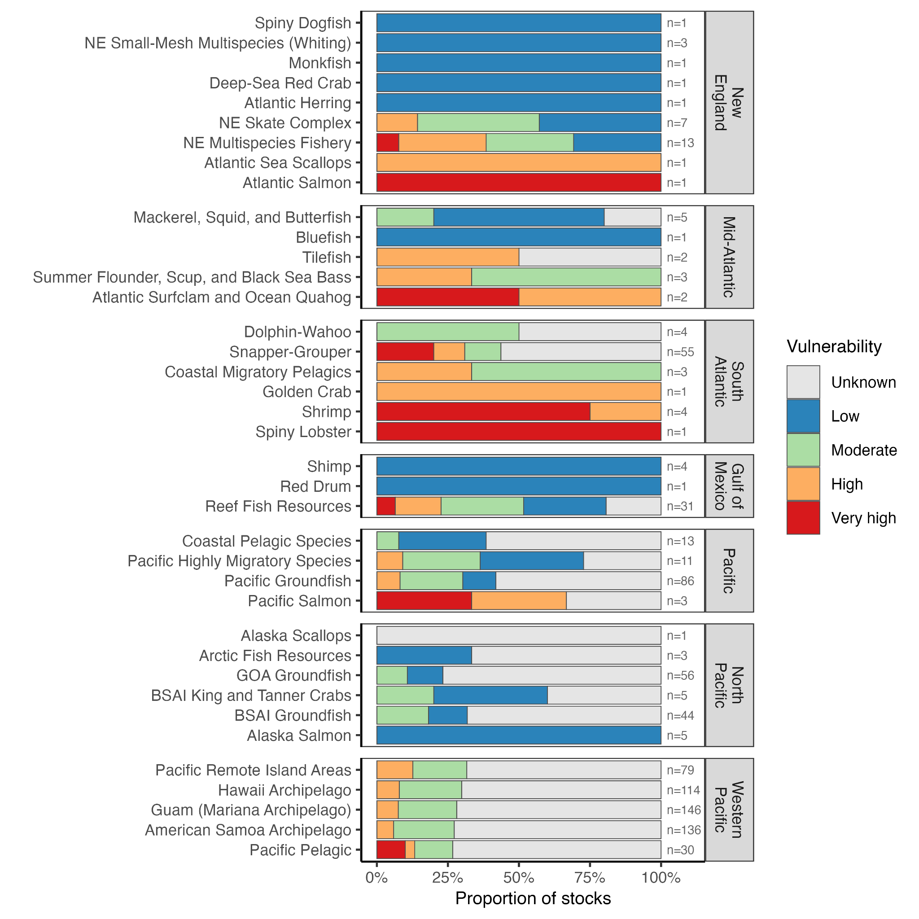

***Figure 13.*** *The climate vulnerability of targeted species managed by each Fishery Management Plan (FMP) or Fishery Ecosystem Plan (FEP) based on regional Climate Vulnerability Assessments (CVAs). FMP/FEPs are grouped by regional Fishery Management Council and are ordered by the average climate vulnerability of target species managed by the FMP/FEP. The number of species in the FMP/FEP is printed in gray text.*

##### 5.2.2. Distribution shifts

Medium or high certainty regional projections were available for 102 of the 1031 unique taxa/regions represented by federal stocks managed by the North Pacific, Pacific, New England, South Atlantic, Mid-Atlantic, and Gulf of Mexico FMCs. Projections were based on fisheries independent bottom trawl survey data, which are not available in the jurisdictions of the Western Pacific or Caribbean FMCs. Projected range shifts (including both RCP 2.6 and 8.5) ranged from 0 km (wrenchman *Pristipomoides aquilonaris* under RCP 2.6 managed through the Gulf of Mexico Reef Fish FMP) to 1714 km (redstripe rockfish *Sebastes proriger* under RCP 8.5 managed through the Groundfish of the Gulf of Alaska FMP). Pulling from the distribution of projected range shifts across species and RCPs, we classified average shifts between 0 and 71 km as mild (1st quartile), between 72 and 189 km as moderate (2nd quartile) between 190 and 406 km as pronounced (3rd quartile), and between 407 and 1714 km as extreme (4th quartile). Based on the range shift projection analysis for the subset of species with projections available, strong candidates for policy review and subsequent integration of best practices for climate-adaptive allocation strategies are described below:

* **New England:** The NE Skate Complex, NE Multispecies, and NE Small-Mesh Multispecies FMPs are strong candidates for policy review because they are predicted to experience extreme stock shifts under RCP 8.5.
* **Mid-Atlantic:** The Mackerel, Squid, and Butterfish FMP is a strong candidate for policy review because it is expected to experience pronounced stock shifts under RCP 8.5.
* **South Atlantic:** The Snapper-Grouper FMP is a strong candidate for policy review because it is expected to experience pronounced stock shifts under RCP 8.5.
* **Gulf of Mexico:** No FMPs were strong candidates for policy review as all average range shifts were classified as mild or moderate.
* **Pacific:** Both FMPs with stock projections available in the Pacific (Coastal Pelagic Species and Pacific Groundfish) are expected to undergo pronounced range shifts under RCP 2.6 and extreme range shifts under RCP 8.5, and are therefore strong candidates for policy review and potential reform.
* **North Pacific:** The Groundfish of the Gulf of Alaska (GOA), Alaska Scallops, and Alaska Salmon FMPs are all strong candidates for policy review. GOA groundfish stocks are expected to experience a pronounced shift under RCP 2.6 and an extreme shift under RCP 8.5. Scallops are expected to undergo an extreme shift under RCP 8.5. Salmon are expected to undergo a pronounced shift under RCP 8.5.

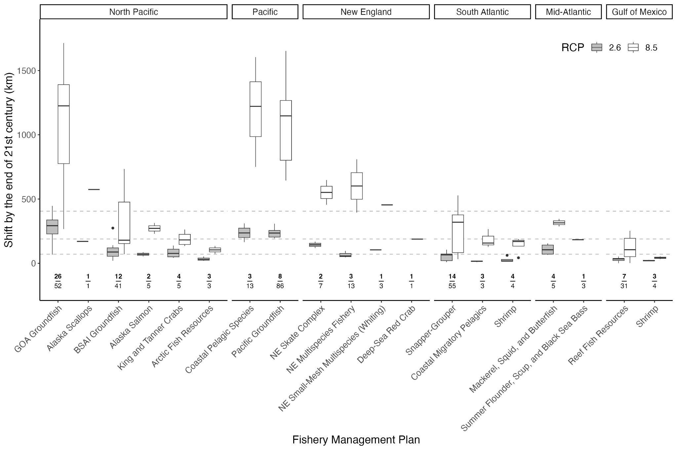

***Figure 14.*** *The projected range shift of targeted species managed by each Fishery Management Plan (FMP) based on species distribution models by Morley et al. 2018 for low (RCP 2.6, gray) and high (RCP 8.5, white) emissions scenarios. FMPs are grouped by regional Fishery Management Council (FMC). FMC and FMPs decrease in magnitude of shift from left to right. The number of species in the FMP for which region-specific medium or high projections exist is printed above the FMP on the x-axis in bold above the total number of species managed by the FMP. Horizontal dashed lines represent 1st quartile, the median, and the 3rd quartile of projected range shifts across regions. In the boxplots, the solid line indicates the median, the box indicates the interquartile range (IQR; 1st to 3rd quartile), the whiskers indicate 1.5 times the IQR, and points indicate outliers.*

Stocks expected to undergo range shifts that are also currently managed through spatial allocation policies are especially strong candidates for policy review to effectively integrate climate-adaptive management practices. The following stocks are managed using spatial allocation and projected to experience pronounced or extreme range shifts:

* **Mid-Atlantic FMC**
  + **Atlantic mackerel:** Atlantic mackerel (*Scomber scombrus*) is managed by the Mid-Atlantic FMC through the Mackerel, Squid, and Butterfish FMP. Within the Northeast US, the species is expected to undergo a pronounced shift of 315 km under RCP 8.5. This will pose a challenge for international allocation policies between the U.S. and Canada.
  + **Scup:** Scup (*Stenotomus chrysops*) is managed by the Mid-Atlantic FMC through the Summer Flounder, Scup, and Black Sea Bass FMP from the U.S.-Canadian border to Cape Hatteras, North Carolina. Within the Northeast US, the species is expected to experience a pronounced range shift of 203 km under RCP 2.6. This shift in resource distribution will pose a challenge for state-based allocations.
* **Pacific FMC**
  + **Northern anchovy:** Northern anchovy (*Engraulis mordax*) is managed by the Pacific FMC through the Coastal Pelagic Species FMP. Along the US East Coast, the species is expected to undergo a pronounced shift of 236 km under RCP 2.6, and an extreme shift of 1221 km under RCP 8.5. This will pose a challenge for international allocation policies between the US and Mexico.
  + **Pacific chub mackerel:** Pacific chub mackerel (*Scomber japonicus*) is managed by the Pacific FMC through the Coastal Pelagic Species FMP. Off of the U.S. west coast, the species is expected to undergo a pronounced shift of 310 km under RCP 2.6 and an extreme shift of 1604 km under RCP 8.5. The stock is allocated between the U.S. and Mexico, and therefore range shifts could pose challenges to existing policy.
* **North Pacific FMC**
  + **Atka mackerel:** Atka mackerel (*Pleurogrammus monopterygius*) in the Bering Sea and Aleutian Islands is managed by the North Pacific FMC through the Groundfish FMP. Atka mackerel in this region are expected to undergo a pronounced shift of 284 km under RCP 8.5. In an effort to avoid local depletion, the complex is currently allocated among three subregions.
  + **Blackspotted and rougheye rockfish complex**: The fishery for blackspotted and rougheye rockfish is managed in the Bering Sea and Aleutian Islands by the North Pacific FMC through the Groundfish FMP. Within this large region of the northeast Pacific, the blackspotted rockfish (*S. melanostictus*) is expected to undergo an extreme range shift of 448 km, and the rougheye rockfish (*S. aleutianus*) is expected to undergo an extreme range shift of 563 km under RCP 8.5. The complex is currently allocated between 1) the western and central Aleutian Islands, and 2) eastern Aleutian Islands and eastern Bering Sea, and therefore these extreme range shifts warrant policy review.
  + **Chinook salmon:** Chinook salmon (*Oncorhynchus tshawytscha*) is managed by the North Pacific FMC through the Salmon Fisheries of the EEZ off the Coast of Alaska FMP. Within the Eastern Bering Sea, the species is expected to undergo a pronounced range shift of 229.9 km under RCP 8.5. This will pose a challenge for international allocation policies between the U.S. and Canada.
  + **Pacific ocean perch:** The fishery for Pacific ocean perch (*Sebastes alutus*) in the Gulf of Alaska is managed by the North Pacific FMC through the Groundfish FMP. Within this region, the species is expected to undergo a pronounced shift of 203 km under a low emissions scenario, and an extreme shift of 768 km under RCP 8.5. This will pose a challenge for spatial allocations across the Gulf of Alaska. Multiple other rockfish that are spatially allocated in the Gulf of Alaska are also expected to undergo pronounced or extreme range shifts, making the GOA Groundfish FMP an especially strong candidate for allocation policy review and integration of climate-ready practices (i.e., aurora [*S. aurora*], canary [*S. pinniger*], redbanded [*S. babcocki*], redstripe [*S. proriger*], sharpchin [*S. zacentrus*], shortraker [*S. borealis*], shortspine [*S. altivelis*], silvergray [*S. brevispinus*], splitnose [*S. diplopia*], yelloweye [*S. ruberrimus*]).

##### 5.2.3. Synthesis

Using assessments of climate vulnerability from both regional CVAs and projected distribution shifts under climate change, we identified 17 FMP/FEPs and 11 stocks that are strong candidates for policy review (**Table 2**).

***Table 2.*** *FMPs and spatially allocated stocks identified as strong candidates for policy review on Climate Vulnerability Assessments (CVAs) and projected distribution shifts. Bolded FMPs indicate agreement between the two analytical approaches. NE=Northeast; GOA=Gulf of Alaska; BSAI=Bering Sea Aleutian Islands.*

|  |  |  |  |
| --- | --- | --- | --- |
| **Region** | **Climate vulnerability** | **Distribution shifts** | **Spatially allocated stock** |
| New England | **NE Multispecies**  **NE Skate Complex**  Atlantic Sea Scallops | **NE Multispecies**  **NE Skate Complex**  NE Small-Mesh Multispecies |  |
| Mid-Atlantic | Summer Flounder, Scup, Black Sea Bass | Mackerel, Squid, Butterfish | Atlantic mackerel  Scup |
| South Atlantic | **Snapper-Grouper** | **Snapper-Grouper** |  |
| Gulf of Mexico | Reef Fish Resources |  |  |
| Pacific | **Groundfish**  Pacific Salmon | **Groundfish**  Coastal Pelagic Species | Northern anchovy  Pacific chub mackerel |
| North Pacific | Groundfish **(GOA/**BSAI**)**  Crab | Groundfish **(GOA)**  Scallops  Salmon | Pacific ocean perch (GOA)  Demersal shelf rockfish (GOA)  Thornyhead rockfish complex (GOA)  Other rockfish complex (GOA)  Atka mackerel (BSAI)  Blackspotted and rougheye rockfish (BSAI)  Chinook salmon (BSAI) |
| Western Pacific | Pacific Pelagic | *Not available* |  |
| Caribbean | *No CVA available* | *Not available* |  |

### 6. Conclusions

Quota allocations are a highly versatile fisheries management tool. They can be used to promote fairness and equity, improve economic efficiency, prevent local depletion, avoid catch limit overages, reduce bycatch, and curb the race to fish. However, without adaptive management, climate change threatens the ability for these important policies to achieve their intended objectives by altering the abundance, distribution, and phenology of both target and non-target species. First and foremost, the success of adaptive management depends on clearly defined management objectives so that the performance of management strategies can be regularly evaluated and updated when needed. Given the “fairness and equity” objectives common to most national and international allocation policies, a much needed first step for operationalizing adaptive quota allocation management is clearly defining these lofty but murky concepts. In the absence of clear definitions, the vast majority of quota allocation policies have envisioned “fairness and equity” as the maintenance of historical access to fishing opportunities. However, the continuation of such an objective under directional climate change is ill-advised if not impossible. This opens the door for envisioning new fairness and equity objectives that could focus on incorporating historically excluded participants, creating opportunities for new entrants, or offsetting negative impacts from climate change, offshore wind development, or other factors inhibiting fisheries, all while protecting opportunities for historical participants and providing time for them to adapt as stocks shift beneath them. Here, through an analysis of “bright spots” of climate-adaptive allocation policies, we provide a roadmap toward helping allocation policies to achieve their fairness and equity goals in a rapidly changing ocean.

### 

### Acknowledgements

This research was funded by the Walton Family Foundation. We are grateful to the following industry stakeholders for their insightful feedback on our recommended best practices: Matt Alward (North Pacific), Rick Bellevance (New England), Susan Boggs (Gulf of Mexico), Dan Farnham (Mid-Atlantic), Hannah Heimbuch (North Pacific), and Wes Townsend (Mid-Atlantic).

### Data availability statement

All of the data used in the paper are either available in the supplemental materials or in the following GitHub repository: <https://github.com/zoekitchel/cc_allocation>

### Conflict of interests statement

CMF serves on the Scientific and Statistical Committee (SSC) of the Pacific Fisheries Management Council (PFMC). The other authors have no conflicts of interest to declare.

### References

[§ 600.325 National Standard 4—Allocations, Pub. L. No. 600.325, 50 CFR (1998).](https://www.zotero.org/google-docs/?QTcmR9)

[§ 600.330 National Standard 5—Efficiency, Pub. L. No. 600.330, 50 CFR (1998). https://www.ecfr.gov/current/title-50/part-600/section-600.330](https://www.zotero.org/google-docs/?QTcmR9)

[AFMF. (2010). *National Statement of Intent on Fisheries and Aquaculture*. Australian Fisheries Management Forum. https://www.daf.qld.gov.au/__data/assets/pdf_file/0006/1875552/australian-fisheries-management-forum-statement.pdf](https://www.zotero.org/google-docs/?QTcmR9)

[Andrushchenko, I. A., Brooks, E. N., & Way-Nee, E. (2022). *Allocation Shares for Canada and the USA of the Transboundary Resources of Atlantic Cod, Haddock, and Yellowtail Flounder on Georges Bank Through Fishing Year 2023*. https://repository.library.noaa.gov/view/noaa/46450](https://www.zotero.org/google-docs/?QTcmR9)

[Aqorau, T., Bell, J., & Kittinger, J. N. (2018). Good governance for migratory species. *Science*, *361*(6408), 1208–1209. https://doi.org/10.1126/science.aav2051](https://www.zotero.org/google-docs/?QTcmR9)

[Bahri, T., Vasconcellos, M., Welch, D. J., Johnson, J., Perry, R. I., Ma, X., & Sharma, R. (2021). *Adaptive management of fisheries in response to climate change* (FAO Fisheries and Aquaculture Technical Paper 667). United Nations Food and Agricultural Organization (FAO). https://doi.org/10.4060/cb3095en](https://www.zotero.org/google-docs/?QTcmR9)

[Bell, J. D., Ganachaud, A., Gehrke, P. C., Griffiths, S. P., Hobday, A. J., Hoegh-Guldberg, O., Johnson, J. E., Le Borgne, R., Lehodey, P., Lough, J. M., Matear, R. J., Pickering, T. D., Pratchett, M. S., Gupta, A. S., Senina, I., & Waycott, M. (2013). Mixed responses of tropical Pacific fisheries and aquaculture to climate change. *Nature Climate Change*, *3*(6), Article 6. https://doi.org/10.1038/nclimate1838](https://www.zotero.org/google-docs/?QTcmR9)

[Biggs, C., & Nemeth, R. (2016). Spatial and temporal movement patterns of two snapper species at a multi-species spawning aggregation. *Marine Ecology Progress Series*, *558*, 129–142. https://doi.org/10.3354/meps11846](https://www.zotero.org/google-docs/?QTcmR9)

[Birkenbach, A. M., Kaczan, D. J., & Smith, M. D. (2017). Catch shares slow the race to fish. *Nature*, *544*(7649), Article 7649. https://doi.org/10.1038/nature21728](https://www.zotero.org/google-docs/?QTcmR9)

[Bonito, L., Bellquist, L., Jackson, A. M., Kauer, K., Gleason, M. G., Wilson, J., & Sandin, S. (2022). U.S. exempted fishing permits: Role, value, and lessons learned for adaptive fisheries management. *Marine Policy*, *138*, 104992. https://doi.org/10.1016/j.marpol.2022.104992](https://www.zotero.org/google-docs/?QTcmR9)

[Brinson, A., & Thunberg, E. (2016). Performance of federally managed catch share fisheries in the United States. *Fisheries Research*, *179*, 213–223. https://doi.org/10.1016/j.fishres.2016.03.008](https://www.zotero.org/google-docs/?QTcmR9)

[Burton, M. L., Muñoz, R. C., & Quinlan, J. A. (2023). *A Climate Vulnerability Assessment for Fish and Invertebrates in the United States South Atlantic Large Marine Ecosystem* (NOAA Technical Memorandum NMFS-SEFSC-768). Southeast Fisheries Science Center. https://repository.library.noaa.gov/view/noaa/55543](https://www.zotero.org/google-docs/?QTcmR9)

[Carson, E. W., Saillant, E. A., Renshaw, M. A., Cummings, N. J., & Gold, J. R. (2011). Population Structure, Long-Term Connectivity, and Effective Size of Mutton Snapper (Lutjanus analis) In the Caribbean Sea and Florida Keys. *Fishery Bulletin*, *109*(4), 416–428.](https://www.zotero.org/google-docs/?QTcmR9)

[Cline, T. J., Schindler, D. E., & Hilborn, R. (2017). Fisheries portfolio diversification and turnover buffer Alaskan fishing communities from abrupt resource and market changes. *Nature Communications*, *8*, 14042. https://doi.org/10.1038/ncomms14042](https://www.zotero.org/google-docs/?QTcmR9)

[Colburn, L. L., Jepson, M., Weng, C., Seara, T., Weiss, J., & Hare, J. A. (2016). Indicators of climate change and social vulnerability in fishing dependent communities along the Eastern and Gulf Coasts of the United States. *Marine Policy*, *74*, 323–333. https://doi.org/10.1016/j.marpol.2016.04.030](https://www.zotero.org/google-docs/?QTcmR9)

[Coleman, F., Koenig, C., Eklund, A. M., & Grimes, C. (1999). Management and conservation of temperate reef fishes in the grouper-snapper complex of the southeastern United States. *Am. Fish. Soc. Symp.*, *23*, 233–242.](https://www.zotero.org/google-docs/?QTcmR9)

[Costello, C., Gaines, S. D., & Lynham, J. (2008). Can Catch Shares Prevent Fisheries Collapse? *Science*, *321*(5896), 1678–1681. https://doi.org/10.1126/science.1159478](https://www.zotero.org/google-docs/?QTcmR9)

[Cox, A. (2009). *Quota Allocation in International Fisheries* (OECD Food, Agriculture and Fisheries Papers 22; OECD Food, Agriculture and Fisheries Papers, Vol. 22). OECD Publishing. https://doi.org/10.1787/218520326143](https://www.zotero.org/google-docs/?QTcmR9)

[Cramer, L. A., Flathers, C., Caracciolo, D., Russell, S. M., & Conway, F. (2018). Graying of the fleet: Perceived impacts on coastal resilience and local policy. *Marine Policy*, *96*, 27–35. https://doi.org/10.1016/j.marpol.2018.07.012](https://www.zotero.org/google-docs/?QTcmR9)

[Criddle, K. R., & Strong, J. (2013). Dysfunction by design: Consequences of limitations on transferability of catch shares in the Alaska pollock fishery. *Marine Policy*, *40*, 91–99. https://doi.org/10.1016/j.marpol.2013.01.006](https://www.zotero.org/google-docs/?QTcmR9)

[Cullenberg, P., Donkersloot, R., Carothers, C., Coleman, J., & Ringer, D. (2017). *Turning the tide: How can Alaska address the “graying of the fleet” and loss of rural fisheries access?* (A Review of Programs and Policies to Address Access Challenges in Alaska Fisheries). https://repository.library.noaa.gov/view/noaa/40752](https://www.zotero.org/google-docs/?QTcmR9)

[Edwards, S. F. (1990). *An economics guide to allocation of fish stocks between commercial and recreational fisheries* (NOAA Technical Report NMFS 94). https://repository.library.noaa.gov/view/noaa/5953](https://www.zotero.org/google-docs/?QTcmR9)

[Fisheries of New Zealand. (2024a). *Fisheries Infosite: Species Catch*. https://fs.fish.govt.nz/Page.aspx?pk=6&tk=97](https://www.zotero.org/google-docs/?QTcmR9)

[Fisheries of New Zealand. (2024b, May 27). *Commercial fishing annual catch entitlement (ACE)*. Ministry for Primary Industries; Ministry for Primary Industries. https://www.mpi.govt.nz/fishing-aquaculture/commercial-fishing/operating-as-a-commercial-fisher/commercial-fishing-annual-catch-entitlement/](https://www.zotero.org/google-docs/?QTcmR9)

[FLSF. (2010). *Allocation across the regional fishery management councils*. Fisheries Leadership & Sustainability Forum. https://nicholasinstitute.duke.edu/sites/default/files/publications/11420_FLSF_RegionalAllocationReport2010-paper.pdf](https://www.zotero.org/google-docs/?QTcmR9)

[FRDC. (2012). *Principles and Guidelines in Support of Fisheries Inter-Sectoral Access and Allocation Decisions*. Fisheries Research and Development Corporation. https://www.frdc.com.au/sites/default/files/products/2013-028%20-%20Resource%20access%20and%20allocation%20July%202012.pdf](https://www.zotero.org/google-docs/?QTcmR9)

[Free, C. M., Anderson, S. C., Hellmers, E. A., Muhling, B. A., Navarro, M. O., Richerson, K., Rogers, L. A., Satterthwaite, W. H., Thompson, A. R., Burt, J. M., Gaines, S. D., Marshall, K. N., White, J. W., & Bellquist, L. F. (2023). Impact of the 2014–2016 marine heatwave on US and Canada West Coast fisheries: Surprises and lessons from key case studies. *Fish and Fisheries*, *24:*, 652–674. https://doi.org/10.1111/faf.12753](https://www.zotero.org/google-docs/?QTcmR9)

[Free, C. M., Mangin, T., Wiedenmann, J., Smith, C., McVeigh, H., & Gaines, S. D. (2023). Harvest control rules used in US federal fisheries management and implications for climate resilience. *Fish and Fisheries*, *24*(2), 248–262. https://doi.org/10.1111/faf.12724](https://www.zotero.org/google-docs/?QTcmR9)

[Gaines, S. D., Costello, C., Owashi, B., Mangin, T., Bone, J., Molinos, J. G., Burden, M., Dennis, H., Halpern, B. S., Kappel, C. V., Kleisner, K. M., & Ovando, D. (2018). Improved fisheries management could offset many negative effects of climate change. *Science Advances*, *4*(8), eaao1378. https://doi.org/10.1126/sciadv.aao1378](https://www.zotero.org/google-docs/?QTcmR9)

[Giddens, J., Kobayashi, D. R., Mukai, G. N. M., Asher, J., Birkeland, C., Fitchett, M., Hixon, M. A., Hutchinson, M., Mundy, B. C., O’Malley, J. M., Sabater, M., Scott, M., Stahl, J., Toonen, R., Trianni, M., Woodworth-Jefcoats, P. A., Wren, J. L. K., & Nelson, M. (2022). Assessing the vulnerability of marine life to climate change in the Pacific Islands region. *PLOS ONE*, *17*(7), e0270930. https://doi.org/10.1371/journal.pone.0270930](https://www.zotero.org/google-docs/?QTcmR9)

[Hare, J. A., Morrison, W. E., Nelson, M. W., Stachura, M. M., Teeters, E. J., Griffis, R. B., Alexander, M. A., Scott, J. D., Alade, L., Bell, R. J., Chute, A. S., Curti, K. L., Curtis, T. H., Kircheis, D., Kocik, J. F., Lucey, S. M., McCandless, C. T., Milke, L. M., Richardson, D. E., … Griswold, C. A. (2016). A Vulnerability Assessment of Fish and Invertebrates to Climate Change on the Northeast U.S. Continental Shelf. *PLOS ONE*, *11*(2), e0146756. https://doi.org/10.1371/journal.pone.0146756](https://www.zotero.org/google-docs/?QTcmR9)

[Heen, E. E., Heen, K., & Leung, P. (2014). Conflicting goals in fisheries management—A study of the Norwegian cod fisheries. *Marine Policy*, *49*, 73–80. https://doi.org/10.1016/j.marpol.2014.03.014](https://www.zotero.org/google-docs/?QTcmR9)

[Himes-Cornell, A., & Kasperski, S. (2015). Assessing climate change vulnerability in Alaska’s fishing communities. *Fisheries Research*, *162*, 1–11. https://doi.org/10.1016/j.fishres.2014.09.010](https://www.zotero.org/google-docs/?QTcmR9)

[Holland, D. S., Speir, C., Agar, J., Crosson, S., DePiper, G., Kasperski, S., Kitts, A. W., & Perruso, L. (2017). Impact of catch shares on diversification of fishers’ income and risk. *Proceedings of the National Academy of Sciences*, *114*(35), 9302–9307. https://doi.org/10.1073/pnas.1702382114](https://www.zotero.org/google-docs/?QTcmR9)

[Hudson, M. (2022, July 6). *Māori hold a third of NZ’s fishing interests, but as the ocean warms and fish migrate, these rights don’t move with them*. The Conversation. http://theconversation.com/maori-hold-a-third-of-nzs-fishing-interests-but-as-the-ocean-warms-and-fish-migrate-these-rights-dont-move-with-them-186284](https://www.zotero.org/google-docs/?QTcmR9)

[IPCC. (2019). *IPCC Special Report on the Ocean and Cryosphere in a Changing Climate*. https://www.ipcc.ch/site/assets/uploads/sites/3/2022/03/SROCC_FullReport_FINAL.pdf](https://www.zotero.org/google-docs/?QTcmR9)

[Jenkins, L. D., & Garrison, K. (2013). Fishing gear substitution to reduce bycatch and habitat impacts: An example of social–ecological research to inform policy. *Marine Policy*, *38*, 293–303. https://doi.org/10.1016/j.marpol.2012.06.005](https://www.zotero.org/google-docs/?QTcmR9)

[Jepson, M., & Colburn, L. L. (2013). *Development of Social Indicators of Fishing Community Vulnerability and Resilience in the U.S. Southeast and Northeast Regions* (NOAA Technical Memorandum NMFS-F/SPO-129). U.S. Dept. of Commerce.](https://www.zotero.org/google-docs/?QTcmR9)

[Kauer, K., Bellquist, L., Humberstone, J., Saccomanno, V., Oberhoff, D., Flumerfelt, S., & Gleason, M. (2024). Advancing fisheries sustainability and access through community fisheries trusts. *Marine Policy*, *165*, 106210. https://doi.org/10.1016/j.marpol.2024.106210](https://www.zotero.org/google-docs/?QTcmR9)

[Knuckey, I., Sen, S., & McShane, P. (2019). *Review of fishery resource access and allocation arrangements across Australian jurisdictions* (FRDC Project 2017/122). Fishwell Consulting.](https://www.zotero.org/google-docs/?QTcmR9)

[Koehn, L. E., Nelson, L. K., Samhouri, J. F., Norman, K. C., Jacox, M. G., Cullen, A. C., Fiechter, J., Pozo Buil, M., & Levin, P. S. (2022). Social-ecological vulnerability of fishing communities to climate change: A U.S. West Coast case study. *PLOS ONE*, *17*(8), e0272120. https://doi.org/10.1371/journal.pone.0272120](https://www.zotero.org/google-docs/?QTcmR9)

[Kourantidou, M., Hoagland, P., Dale, A., & Bailey, M. (2021). Equitable Allocations in Northern Fisheries: Bridging the Divide for Labrador Inuit. *Frontiers in Marine Science*, *8*. https://doi.org/10.3389/fmars.2021.590213](https://www.zotero.org/google-docs/?QTcmR9)

[Lapointe, G. (2012). *Marine Fishery Allocation Issues: Findings, discussion, and options*. George Lapointe Consulting LLC.](https://www.zotero.org/google-docs/?QTcmR9)

[Lehodey, P., Bertignac, M., Hampton, J., Lewis, A., & Picaut, J. (1997). El Niño Southern Oscillation and tuna in the western Pacific. *Nature*, *389*(6652), 715–718. https://doi.org/10.1038/39575](https://www.zotero.org/google-docs/?QTcmR9)

[Lock, K., & Leslie, S. (2007). 3. Allocation, Trade and Holding of Quota. In *New Zealand’s Quota Management System: A History of the First 20 Years*. Motu Economic and Public Policy Research. https://fs.fish.govt.nz/NR/rdonlyres/C720A226-A8A9-46BE-87F3-3EABB8D7E248/0/qms_chapter_03_allocation_trade_holding.pdf](https://www.zotero.org/google-docs/?QTcmR9)

[Lynham, J. (2014). How have catch shares been allocated? *Marine Policy*, *44*, 42–48. https://doi.org/10.1016/j.marpol.2013.08.007](https://www.zotero.org/google-docs/?QTcmR9)

[MAFMC. (2021a). *Bluefish Allocation And Rebuilding Amendment: Amendment 7 To The Bluefish Fishery Management Plan*. https://static1.squarespace.com/static/511cdc7fe4b00307a2628ac6/t/613104477cc5457c839fe04c/1630602830744/Bluefish+Amendment+7+EA.pdf](https://www.zotero.org/google-docs/?QTcmR9)

[MAFMC. (2021b). *Comprehensive Mid-Atlantic Research Set-Aside Timeline*. https://static1.squarespace.com/static/511cdc7fe4b00307a2628ac6/t/60ba892443dd500cdcf2a39a/1622838915591/4_Comprehensive+Mid-Atlantic+RSA+Timeline.pdf](https://www.zotero.org/google-docs/?QTcmR9)

[MAFMC. (2024). *Research Set-Aside Program*. Mid-Atlantic Fishery Management Council. https://www.mafmc.org/research-set-aside](https://www.zotero.org/google-docs/?QTcmR9)

[Maine DMR. (2022). *Maine Groundfish Permit Bank*. Department of Marine Resources. https://www.maine.gov/dmr/fisheries/commercial/fisheries-by-species/groundfish-multispecies/maine-groundfish-permit-bank](https://www.zotero.org/google-docs/?QTcmR9)

[Mardle, S., Pascoe, S., Tamiz, M., & Jones, D. (2000). Resource allocation in the North Sea demersal fisheries: A goal programming approach. *Annals of Operations Research*, *94*, 321–342.](https://www.zotero.org/google-docs/?QTcmR9)

[Mason, J. G., Eurich, J. G., Lau, J. D., Battista, W., Free, C. M., Mills, K. E., Tokunaga, K., Zhao, L. Z., Dickey-Collas, M., Valle, M., Pecl, G. T., Cinner, J. E., McClanahan, T. R., Allison, E. H., Friedman, W. R., Silva, C., Yáñez, E., Barbieri, M. Á., & Kleisner, K. M. (2022). Attributes of climate resilience in fisheries: From theory to practice. *Fish and Fisheries*, *n/a*(n/a). https://doi.org/10.1111/faf.12630](https://www.zotero.org/google-docs/?QTcmR9)

[Maureaud, A. A., Palacios-Abrantes, J., Kitchel, Z., Mannocci, L., Pinsky, M. L., Fredston, A., Beukhof, E., Forrest, D. L., Frelat, R., Palomares, M. L. D., Pecuchet, L., Thorson, J. T., van Denderen, P. D., & Mérigot, B. (2024). FISHGLOB_data: An integrated dataset of fish biodiversity sampled with scientific bottom-trawl surveys. *Scientific Data*, *11*(1), 24. https://doi.org/10.1038/s41597-023-02866-w](https://www.zotero.org/google-docs/?QTcmR9)

[Mazur, K., Bath, A., Savage, J., & Curtotti R, R. (2020). *Allocating fish stocks between commercial and recreational fishers—Examples from Australia and overseas*. https://doi.org/10.25814/5EC4BD22339DA](https://www.zotero.org/google-docs/?QTcmR9)

[McClure, M. M., Haltuch, M. A., Willis-Norton, E., Huff, D. D., Hazen, E. L., Crozier, L. G., Jacox, M. G., Nelson, M. W., Andrews, K. S., Barnett, L. A. K., Berger, A. M., Beyer, S., Bizzarro, J., Boughton, D., Cope, J. M., Carr, M., Dewar, H., Dick, E., Dorval, E., … Bograd, S. J. (2023). Vulnerability to climate change of managed stocks in the California Current large marine ecosystem. *Frontiers in Marine Science*, *10*, 1103767. https://doi.org/10.3389/fmars.2023.1103767](https://www.zotero.org/google-docs/?QTcmR9)

[McShane, P., Knuckey, I., & Sen, S. (2021). Access and allocation in fisheries: The Australian experience. *Marine Policy*, *132*, 104702. https://doi.org/10.1016/j.marpol.2021.104702](https://www.zotero.org/google-docs/?QTcmR9)

[Morley, J. W., Selden, R. L., Latour, R. J., Frölicher, T. L., Seagraves, R. J., & Pinsky, M. L. (2018). Projecting shifts in thermal habitat for 686 species on the North American continental shelf. *PLOS ONE*, *13*(5), e0196127. https://doi.org/10.1371/journal.pone.0196127](https://www.zotero.org/google-docs/?QTcmR9)

[Morrison, W. (2016a). *Criteria for Initiating Fisheries Allocation Reviews Council Coordinating Committee Allocation Workgroup Guidance Document* (National Marine Fisheries Service Procedure 01-119–01). National Marine Fisheries Service.](https://www.zotero.org/google-docs/?QTcmR9)

[Morrison, W. (2016b). *Recommended Practices and Factors to Consider When Reviewing and Making Allocation Decisions* (National Marine Fisheries Service Procedure 01-119–02). National Marine Fisheries Service.](https://www.zotero.org/google-docs/?QTcmR9)

[Morrison, W. (2017a). *Catch Share Policy* (National Marine Fisheries Service Policy 01–121). National Marine Fisheries Service.](https://www.zotero.org/google-docs/?QTcmR9)

[Morrison, W. (2017b). *Fisheries Allocation Review Policy* (National Marine Fisheries Service Policy 01–119). National Marine Fisheries Service.](https://www.zotero.org/google-docs/?QTcmR9)

[Morrison, W. (2017c). *Guidance for Conducting Review of Catch Share Programs* (National Marine Fisheries Service Procedure 01-121–01). National Marine Fisheries Service.](https://www.zotero.org/google-docs/?QTcmR9)

[Morrison, W. E., Nelson, M. W., Griffis, R. B., & Hare, J. A. (2016). Methodology for Assessing the Vulnerability of Marine and Anadromous Fish Stocks in a Changing Climate. *Fisheries*, *41*(7), 407–409. https://doi.org/10.1080/03632415.2016.1182507](https://www.zotero.org/google-docs/?QTcmR9)

[Morrison, W. E., Nelson, M. W., Howard, J. F., Hare, J. A., Griffis, R. B., Scott, J. D., & Alexander, M. A. (2015). *Methodology for Assessing the Vulnerability of Marine Fish and Shellfish Species to a Changing Climate* (NOAA Technical Memorandum NMFS-OSF-3). National Marine Fisheries Service.](https://www.zotero.org/google-docs/?QTcmR9)

[Morrison, W. E., & Scott, T. L. (2014). *Review of Laws, Guidance, Technical Memorandums and Case Studies Related to Fisheries Allocation* (NOAA Technical Memorandum NMFS-F/SPO-148). National Marine Fisheries Service.](https://www.zotero.org/google-docs/?QTcmR9)

[NAS. (2024). *Assessing Equity in the Distribution of Fisheries Management Benefits: Data and Information Availability*. National Academies Press. https://doi.org/10.17226/27313](https://www.zotero.org/google-docs/?QTcmR9)

[National Academy. (2006). *Review of Recreational Fisheries Survey Methods* (p. 11616). National Academies Press. https://doi.org/10.17226/11616](https://www.zotero.org/google-docs/?QTcmR9)

[Nayani, S., & Warlick, A. (2018). Implementation Challenges for Quota Set-Asides: Policy Analysis to Inform Fisheries Management Decision-Making. *Coastal Management*, *46*(6), 638–655. https://doi.org/10.1080/08920753.2018.1522493](https://www.zotero.org/google-docs/?QTcmR9)

[Neubauer, P., Thorson, J. T., Melnychuk, M. C., Methot, R., & Blackhart, K. (2018). Drivers and rates of stock assessments in the United States. *PLOS ONE*, *13*(5), e0196483-19. https://doi.org/10.1371/journal.pone.0196483](https://www.zotero.org/google-docs/?QTcmR9)

[Neville, P. (2012). *Principles and Guidelines in Support of Fisheries Inter-Sectoral Access and Allocation Decisions* [FRDC: Fisheries Resource Access and Allocation Project].](https://www.zotero.org/google-docs/?QTcmR9)

[NMFS. (1996). *50 CFR § 600.745—Scientific research activity, exempted fishing, and exempted educational activity*. https://www.govinfo.gov/content/pkg/CFR-2018-title50-vol12/pdf/CFR-2018-title50-vol12-sec600-745.pdf](https://www.zotero.org/google-docs/?QTcmR9)

[NMFS. (2022). *Fisheries Economics of the United States, 2022* (NOAA Technical Memorandum NMFS-F/SPO-248A; p. 28). National Marine Fisheries Service.](https://www.zotero.org/google-docs/?QTcmR9)

[NOAA. (2014). *Environmental Assessment for Continuation of Adaptive Management Program Quota Pounds Pass-Through*.](https://www.zotero.org/google-docs/?QTcmR9)

[NOAA. (2024, May 2). *Research Set-Aside Programs*. NOAA Fisheries. https://www.fisheries.noaa.gov/new-england-mid-atlantic/funding-financial-services/research-set-aside-programs](https://www.zotero.org/google-docs/?QTcmR9)

[NOAA Fisheries. (2024a). *Distribution Mapping and Analysis Portal (DisMAP)*. https://apps-st.fisheries.noaa.gov/dismap/docs/DisMAP_Tech_Report_with_Table_07_2024.pdf](https://www.zotero.org/google-docs/?QTcmR9)

[NOAA Fisheries. (2024b, May 14). *Climate Vulnerability Assessment Tool* (National). https://www.fisheries.noaa.gov/data-tools/climate-vulnerability-assessment-tool](https://www.zotero.org/google-docs/?QTcmR9)

[NPFMC. (2016). *Twenty-Year Review of the Pacific Halibut and Sablefish Individual Fishing Quota Management Program*. North Pacific Fishery Management Council. https://www.npfmc.org/wp-content/PDFdocuments/halibut/IFQProgramReview_417.pdf](https://www.zotero.org/google-docs/?QTcmR9)

[Ojea, E., Pearlman, I., Gaines, S. D., & Lester, S. E. (2017). Fisheries regulatory regimes and resilience to climate change. *Ambio*, *46*(4), 399–412. https://doi.org/10.1007/s13280-016-0850-1](https://www.zotero.org/google-docs/?QTcmR9)

[Palacios-Abrantes, J., Crosson, S., Dumas, C., Fujita, R., Levine, A., Longo, C., & Jensen, O. P. (2023). Quantifying fish range shifts across poorly defined management boundaries. *PLOS ONE*, *18*(1), e0279025. https://doi.org/10.1371/journal.pone.0279025](https://www.zotero.org/google-docs/?QTcmR9)

[Palacios-Abrantes, J., Sumaila, U. R., & Cheung, W. (2020). Challenges to transboundary fisheries management in North America under climate change. *Ecology and Society*, *25*(4). https://doi.org/10.5751/ES-11743-250441](https://www.zotero.org/google-docs/?QTcmR9)

[Papaioannou, E. A., Selden, R. L., Olson, J., McCay, B. J., Pinsky, M. L., & St. Martin, K. (2021). Not All Those Who Wander Are Lost – Responses of Fishers’ Communities to Shifts in the Distribution and Abundance of Fish. *Frontiers in Marine Science*, *8*. https://doi.org/10.3389/fmars.2021.669094](https://www.zotero.org/google-docs/?QTcmR9)

[PFMC. (2021, September). *Pacific Coast Salmon Fishery Management Plan*. Pacific Fishery Management Council. https://www.pcouncil.org/documents/2016/03/salmon-fmp-through-amendment-20.pdf/](https://www.zotero.org/google-docs/?QTcmR9)

[PFMC. (2023a). *Implementing council efficiencies in line with the grant application process staff white paper* (Agenda Item C.2 Attachment 1). Pacific Fishery Management Council. https://www.pcouncil.org/documents/2023/06/c-2-attachment-1-implementing-council-efficiencies-in-line-with-the-grant-application-process.pdf/](https://www.zotero.org/google-docs/?QTcmR9)

[PFMC. (2023b). *Pacific Coast Groundfish Fishery Management Plan*. Pacific Fishery Management Council.](https://www.zotero.org/google-docs/?QTcmR9)

[PFMC & NMFS. (2010). *Rationalization of the Pacific Coast Groundfish Limited Entry Trawl Fishery; Final Environmental Impact Statement Including Regulatory Impact Review and Initial Regulatory Flexibility Analysis*. Pacific Fishery Management Council.](https://www.zotero.org/google-docs/?QTcmR9)

[Pinsky, M. L., & Fogarty, M. (2012). Lagged social-ecological responses to climate and range shifts in fisheries. *Climatic Change*, *115*(3), 883–891. https://doi.org/10.1007/s10584-012-0599-x](https://www.zotero.org/google-docs/?QTcmR9)

[Pinsky, M. L., Reygondeau, G., Caddell, R., Palacios-Abrantes, J., Spijkers, J., & Cheung, W. W. L. (2018). Preparing ocean governance for species on the move. *Science*, *360*(6394), 1189–1191.](https://www.zotero.org/google-docs/?QTcmR9)

[Pinsky, M. L., Worm, B., Fogarty, M. J., Sarmiento, J. L., & Levin, S. A. (2013). Marine taxa track local climate velocities. *Science*, *341*(6151), 1239–1242. https://doi.org/10.1126/science.1239352](https://www.zotero.org/google-docs/?QTcmR9)

[Plummer, M., Morrison, W., & Steiner, E. (2012). *Allocation of Fishery Harvests under the Magnuson-Stevens Fishery Conservation and Management Act: Principles and Practice* (NOAA Technical Memorandum NMFS-NWFSC-115.). Northwest Fisheries Science Center.](https://www.zotero.org/google-docs/?QTcmR9)

[PNA Tuna. (2010). *Nauru Agreement Concerning Cooperation in the Management of Fisheries of Common Stocks (as Amended April 2010)*. PNA Tuna. https://www.pnatuna.com/content/nauru-agreement](https://www.zotero.org/google-docs/?QTcmR9)

[PNA Tuna. (2011). *Purse Seine PNA Vessel Day Scheme*. PNA Tuna. https://www.pnatuna.com/content/pna-vessel-day-scheme](https://www.zotero.org/google-docs/?QTcmR9)

[Pozo Buil, M., Jacox, M. G., Fiechter, J., Alexander, M. A., Bograd, S. J., Curchitser, E. N., Edwards, C. A., Rykaczewski, R. R., & Stock, C. A. (2021). A Dynamically Downscaled Ensemble of Future Projections for the California Current System. *Frontiers in Marine Science*, *8*. https://doi.org/10.3389/fmars.2021.612874](https://www.zotero.org/google-docs/?QTcmR9)

[Productivity Commission. (2016). *Marine Fisheries and Aquaculture, Final Report* (Productivity Commission Inquiry Report 81). Commonwealth of Australia. https://www.pc.gov.au/inquiries/completed/fisheries-aquaculture/report/fisheries-aquaculture.pdf](https://www.zotero.org/google-docs/?QTcmR9)

[Punt, A. E. (2010). Harvest Control Rules and Fisheries Management. In R. Q. Grafton, R. Hilborn, D. Squires, M. Tait, & M. J. Williams (Eds.), *Handbook of Marine Fisheries Conservation and Management* (p. 13). Oxford University Pres.](https://www.zotero.org/google-docs/?QTcmR9)

[Quinlan, J. A., Nelson, M., & Caitlyn Savoia. (2023). *Results from the Gulf of Mexico Climate Vulnerability Analysis for Fishes and Invertebrates* (NOAA Technical Memorandum NMFS-SEFSC-767). Southeast Fisheries Science Center. https://repository.library.noaa.gov/view/noaa/55544](https://www.zotero.org/google-docs/?QTcmR9)

[Ryan, K. L., Trinnie, F. I., Jones, R., Hart, A. M., & Wise, B. S. (2016). Recreational fisheries data requirements for monitoring catch shares. *Fisheries Management and Ecology*, *23*(3–4), 218–233. https://doi.org/10.1111/fme.12151](https://www.zotero.org/google-docs/?QTcmR9)

[Samhouri, J. F., Feist, B. E., Jacox, M., Liu, O. R., Richerson, K., Steiner, E., Wallace, J., Andrews, K., Barnett, L., Beaudreau, A. H., Bellquist, L., Buil, M. P., Haltuch, M. A., Harley, A., Harvey, C. J., Kaplan, I. C., Norman, K., Phillips, A., Rasmuson, L. K., … Selden, R. L. (2024). Stay or go? Geographic variation in risks due to climate change for fishing fleets that adapt in-place or adapt on-the-move. *PLOS Climate*, *3*(2), e0000285. https://doi.org/10.1371/journal.pclm.0000285](https://www.zotero.org/google-docs/?QTcmR9)

[Scherrer, K. J. N., Langbehn, T. J., Ljungström, G., Enberg, K., Hornborg, S., Dingsør, G., & Jørgensen, C. (2024). Spatial restrictions inadvertently doubled the carbon footprint of Norway’s mackerel fishing fleet. *Marine Policy*, *161*, 106014. https://doi.org/10.1016/j.marpol.2024.106014](https://www.zotero.org/google-docs/?QTcmR9)

[Seagraves, R. (2014). *RSA Program Issue* [Memorandum]. Mid-Atlantic Fishery Management Council.](https://www.zotero.org/google-docs/?QTcmR9)

[Smyth, L., Egan, H., & Rod Kennett. (2018). *Livelihood values of Indigenous customary fishing: Final report to the Fisheries Research and Development Corporation* (FRDC Project No 2015/205).](https://www.zotero.org/google-docs/?QTcmR9)

[Soliman, A. (2015). Alaska’s Community Quota Entities Program for Halibut and Sablefish: Between Governability Challenges and Opportunities. In S. Jentoft & R. Chuenpagdee (Eds.), *Interactive Governance for Small-Scale Fisheries: Global Reflections* (pp. 299–318). Springer International Publishing. https://doi.org/10.1007/978-3-319-17034-3_16](https://www.zotero.org/google-docs/?QTcmR9)

[Spencer, P. D., Hollowed, A. B., Sigler, M. F., Hermann, A. J., & Nelson, M. W. (2019). Trait‐based climate vulnerability assessments in data‐rich systems: An application to eastern Bering Sea fish and invertebrate stocks. *Global Change Biology*, *25*(11), 3954–3971. https://doi.org/10.1111/gcb.14763](https://www.zotero.org/google-docs/?QTcmR9)

[Stephen, J. A., Brouwer, M., Errigo, M., Wiegand, C., Hadley, J., Cheuvront, B., Travis, M., Jepson, M., Stephen, J., Gray-Dileone, A., LaVine, B., Grimes, S., Mitchell, K. P., Hughes, B., DeVictor, R., Crosson, S., & Gloeckner, D. (2019). *Review of the Wreckfish Individual Transferable Quota Program of the South Atlantic Fishery Management Council*. South Atlantic Fishery Management Council.](https://www.zotero.org/google-docs/?QTcmR9)

[Tokunaga, K., Kerr, L. A., & Pershing, A. J. (2023). Implications of fisheries allocation policy on anticipated climate change impacts. *Marine Policy*, *148*, 105402. https://doi.org/10.1016/j.marpol.2022.105402](https://www.zotero.org/google-docs/?QTcmR9)

[US GAO. (2020). *Mixed-Use Fisheries: South Atlantic and Gulf of Mexico Councils Would Benefit from Documented Processes for Allocation Reviews* (Report to Congressional Committees GAO-20-216). United States Government Accountability Office. https://www.gao.gov/assets/gao-22-105132.pdf](https://www.zotero.org/google-docs/?QTcmR9)

[US GAO. (2022). *Opportunities Exist to Enhance Climate Resilience* (Report to Congressional Committees GAO-22-105132). United States Government Accountability Office. https://www.gao.gov/assets/gao-22-105132.pdf](https://www.zotero.org/google-docs/?QTcmR9)

[Vogel, J. M., Levine, A., Longo, C., Fujita, R., Alves, C. L., Carroll, G., Craig, J. K., Dancy, K., Errend, M., Essington, T. E., Farchadi, N., Glaser, S., Golden, A. S., Jensen, O. P., LeFlore, M., Mason, J. G., Mills, K. E., Palacios-Abrantes, J., Rogers, A., … Wabnitz, C. C. C. (2024). Fisheries in flux: Bridging science and policy for climate-resilient management of US fisheries under distributional change. *Marine Policy*, *170*, 106385. https://doi.org/10.1016/j.marpol.2024.106385](https://www.zotero.org/google-docs/?QTcmR9)

[Walters, C. J. (2007). Is Adaptive Management Helping to Solve Fisheries Problems? *AMBIO: A Journal of the Human Environment*, *36*(4), 304–307. https://doi.org/10.1579/0044-7447(2007)36[304:IAMHTS]2.0.CO;2](https://www.zotero.org/google-docs/?QTcmR9)

[Walters, C. J., & Hilborn, R. (1976). Adaptive Control of Fishing Systems. *Journal of the Fisheries Research Board of Canada*, *33*(1), 145–159. https://doi.org/10.1139/f76-017](https://www.zotero.org/google-docs/?QTcmR9)

[Young, T., Fuller, E. C., Provost, M. M., Coleman, K. E., St. Martin, K., McCay, B. J., & Pinsky, M. L. (2019). Adaptation strategies of coastal fishing communities as species shift poleward. *ICES Journal of Marine Science*, *76*(1), 93–103. https://doi.org/10.1093/icesjms/fsy140](https://www.zotero.org/google-docs/?QTcmR9)

### 

### Supplemental Tables and Figures

**Table S1.** Fishery Management Plans (FMPs) and Fishery Ecosystem Plans (FEPs) used to manage U.S. federal fish and invertebrate stocks.*

|  |  |  |  |
| --- | --- | --- | --- |
| **FMP/FEP** | **Year** | **# of species** | **# of stocks** |
| *New England (10 FMPs)* |  |  |  |
| Atlantic Sea Scallop | 1982 | 1 | 1 |
| Deep-Sea Red Crab | 2002 | 1 | 1 |
| Northeast Multispecies | 1986 | 13 | 20 |
| Small-Mesh Multispecies (Whiting) | 2000 | 3 | 5 |
| Northeast Skate Complex | 2003 | 7 | 7 |
| Atlantic Herring | 1999 | 1 | 1 |
| Atlantic Salmon | 1988 | 1 | 1 |
| Monkfish *(with MAFMC)* | 1999 | 1 | 1 |
| Spiny Dogfish *(with MAFMC)* | 1999 | 1 | 1 |
| Atlantic HMS *(with all East Coast RFMCs)* | 2006 |  |  |
| *Mid-Atlantic (5 FMPs)* |  |  |  |
| Atlantic Surfclam & Ocean Quahog | 1977 | 2 | 2 |
| Bluefish | 1990 | 1 | 1 |
| Mackerel, Squid, Butterfish | 1978 | 5 | 5 |
| Summer Flounder, Scup, Black Sea Bass | 1988 | 3 | 3 |
| Tilefish | 2001 | 2 | 2 |
| *South Atlantic (6 FMPs)* |  |  |  |
| Dolphin & Wahoo | 2004 | 4 | 4 |
| Golden Crab | 1996 | 1 | 1 |
| Shrimp | 1993 | 4 | 4 |
| Snapper-Grouper | 1983 | 55 | 55 |
| Coastal Migratory Pelagics *(with GFMC)* | 1983 | 3 | 3 |
| GOM & SA Spiny Lobster *(with GFMC)* | 1982 | 1 | 1 |
| *Gulf of Mexico (3 FMPs)* |  |  |  |
| Red Drum | 1986 | 1 | 1 |
| GOM Reef Fish | 1984 | 31 | 31 |
| GOM Shrimp | 1981 | 4 | 4 |
| *Caribbean (3 FMPs)* |  |  |  |
| Puerto Rico | 2022 | 65, plus cucumbers/urchins/corals | 37 |
| St. Thomas & St. John | 2022 | 45, plus cucumbers/urchins/corals | 26 |
| St. Croix | 2022 | 49, plus cucumbers/urchins/corals | 26 |
| *Pacific (4 FMPs)* |  |  |  |
| Coastal Pelagic Species | 2000 | 5 | 5 |
| Pacific Groundfish | 1982 | 86 | 100+ |
| Pacific Salmon | 2016 | 3 | 67 |
| Pacific HMS | 2003 | 11 | 11 |
| *North Pacific (6 FMPs)* |  |  |  |
| BSAI King & Tanner Crabs | 1989 | 5 | 10 |
| Arctic Fish | 2009 | 3 | 3 |
| BSAI Groundfish | 1982 | 17, plus 3 complexes | 23 |
| GOA Groundfish | 1978 | 19, plus 5 complexes | 28 |
| AK Salmon | 1979 | 5 | many |
| AK Scallop | 1995 | 1 | 1 |
| *Western Pacific (5 FEPs)* |  |  |  |
| American Samoa Archipelago | 2009 |  |  |
| Hawaii Archipelago | 2009 |  |  |
| Guam (Mariana Archipelago) | 2009 |  |  |
| Pacific Pelagic Fisheries | 2009 |  |  |
| Pacific Remote Island Areas | 2009 |  |  |

*\* We did not evaluate the following habitat-oriented FMPs because they do not manage fisheries: New England: Habitat; South Atlantic: Coral, Sargassum; Gulf of Mexico: Aquaculture, Coral, Essential Fish Habitat; Pacific: Fishery Ecosystem Plan.*

**Table S2.** Structure of the quota allocation policy database.

|  |  |  |  |
| --- | --- | --- | --- |
| **Description** | **Column name** | **Example** | **Status / notes** |
| Council | council | NEFMC |  |
| Management plan | fmp | Northeast Multispecies |  |
| Stock name | stock | Granger fish - Georges Bank |  |
| Species category | spp_catg | Groundfish |  |
| Common name | comm_name | Granger fish |  |
| Scientific name | sci_name | *Petrificus totalus* |  |
| Catch prohibited (yes/no)? | prohibited_yn | No |  |
| Allocation rule (yes/no)? | allocation_yn | Yes |  |
| Geographic rule (yes/no)? | spatial_yn | Yes | Derive programmatically |
| Country rule (yes/no)? | country_yn | Yes | Derive programmatically |
| List of countries | country_list | US, Canada |  |
| Number of countries | county_n | 2 | Derive programmatically |
| Country reference years | country_yrs | 1985-1990, 1995-2001 |  |
| State rule (yes/no)? | state_yn | Yes |  |
| List of states | state_list | ME, NH, RI |  |
| Number of states | state_n | 3 |  |
| State reference years | state_yrs | 1985-1990 |  |
| Area (yes/no)? | area_yn | Yes |  |
| List of areas | area_list | Georges Bank, Gulf of Maine |  |
| Number of areas | area_n | 2 | Derive programmatically |
| Area reference years | area_yrs | 1985-1990, 1995-2001 |  |
| Sector rule (yes/no)? | sector_yn | Yes |  |
| List of sectors | sector_list | Research, comm, rec, tribal |  |
| Number of sectors | sector_n | 3 |  |
| Basis (catch/effort) | sector_basis | Catch |  |
| Sector reference years | sector_yrs | 1985-1990 |  |
| Subsector rule (yes/no)? | subsector_yn | Yes |  |
| List of subsectors | subsector_list | Longline, gillnet, trap |  |
| Number of subsectors | subsector_n | 3 | Derive programmatically |
| Subsector reference years | subsector_yrs | 1985-1990, 1995-2001 |  |
| Seasonal rule (yes/no)? | season_yn | Yes |  |
| List of seasons | season_list | Jan - May, Jun - Dec |  |
| Number of seasons | season_n | 2 | Derive programmatically |
| Indiv/group rule (yes/no)? | indiv_yn | Yes |  |
| Basis (hist., equal, auction | indiv_basis | Historical catch |  |
| Reference years | indiv_yrs | 1985-1990 |  |
| Owner | indiv_owner | Vessel |  |
| Share caps (yes/no)? | indiv_caps_yn | Yes |  |